Kinetic mechanisms of fast glutamate sensing by fluorescent protein probes

C. Coates, S. Kerruth, N. Helassa and K. Török*

Running title: Fast glutamate sensor kinetics
Keywords: glutamate, biosensor, fluorescence

*To whom correspondence should be addressed

ABSTRACT
We have developed probes based on the bacterial periplasmic glutamate/aspartate binding protein with either an endogenously fluorescent protein or a synthetic fluorophore as the indicator of glutamate binding for studying the kinetic mechanism of glutamate binding. iGluSnFR variants termed iGlu_{h}, iGlu_{m} and iGlu_{l} cover a broad range of K_{d}-s (5.8 μM, 2.1 mM and 50 mM, respectively) and a novel fluorescently labelled indicator, Fl-GluBP has a K_{d} of 9.7 μM. The fluorescence response kinetics of all the probes are consistent with a two-step mechanism involving ligand binding and isomerisation either of the apo or the ligand-bound binding protein. While the previously characterised ultrafast indicators iGlu_{u} and iGlu_{f} had monophasic fluorescence enhancement which occurred in the rate limiting isomerisation step, the sensors described here all have biphasic binding kinetics with fluorescence increases occurring both in the glutamate binding and the isomerisation steps. For iGlu_{m} and iGlu_{l}, the data indicate pre-binding conformational change followed by ligand binding. In contrast, for iGlu_{h} and Fl-GluBP glutamate binding is followed by isomerisation. Thus, the effects of structural heterogeneity introduced by single amino acid changes around the binding site on the kinetic path of interactions with glutamate are revealed. Remarkably, glutamate binding with a diffusion limited rate constant to iGlu_{h} and Fl-GluBP is detected for the first time, hinting at the underlying mechanism of the supremely rapid activation of the highly homologous AMPAR by glutamate binding.

(230 words)
Statement of Significance
Protein-based fluorescent indicators are useful tools for investigating the mechanism of ligand-protein interactions both in vitro and in vivo. Here we report the kinetic mechanisms of a number of glutamate indicator variants based on the bacterial periplasmic glutamate/aspartate binding protein, revealing the subtle differences in their kinetic pathway caused by structural alteration of the glutamate binding protein by point mutations. Diffusion limited glutamate binding indicated by a novel chemically labelled probe hints at the mechanism that underlies the rapid response of the AMPA receptor.

INTRODUCTION
Glutamate is a major excitatory neurotransmitter in the central nervous system, however its synaptic and cellular dynamics have only become possible to investigate with high spatial and temporal resolution with the emergence of well-functioning optical sensors (1,2). The fastest fluorescent glutamate sensors iGluSnFR variants iGlu_{f} and iGlu_{u} have proved useful for tracking high frequency glutamate release at single hippocampal synapses (3) and revealed impaired glutamate clearance at striatal synapses in a Huntington’s disease mouse model (4).
Information processing at synapses is rapid: glutamate neurotransmitter release is fast evoking AMPA receptor (AMPAR) channel opening with a time constant, τ_{on} of 17 μs (5), making AMPAR the fastest responding ligand-gated ion channel. Glutamate clearance from the synapse is predicted to occur with τ_{off} of 50-200 μs (6,7). Visualising synaptic and intracellular glutamate offers an important approach for better understanding of mechanisms of information processing at the synapse and of cellular glutamate homeostasis. For this, sensors with affinities and kinetics appropriate to the physiological conditions are required.
Fluorescent glutamate sensors were initially developed from the extracellular domains of AMPAR, constructs of which are termed S1S2 and later from the bacterial periplasmic glutamate/aspartate binding protein (GluBP). GluR2-AMPAR-derived S1S2 constructs labelled with synthetic fluorophores were promising candidates for the generation of a glutamate biosensor, but have proved impractical due to low refolding yield and stability (8). Following extensive engineering, stable fluorescent S1S2 derivatives with high fluorescence dynamic ranges have been reported (9,10). For a fluorescent S1S2 derivative eEOS, an association rate constant of 1.2 x 10⁵ M⁻¹s⁻¹ and an off-rate of 14 s⁻¹ were measured at 25 °C (10), not representative of the rapid AMPAR glutamate interaction kinetics.
Bacterial periplasmic ligand binding proteins have been widely used for the generation of fluorescent biosensors, initially by covalent derivatisation with synthetic fluorophores, e.g. for inorganic phosphate (11) and amino acid and sugar ligands (12,13). Ligand binding kinetics of members of the bacterial periplasmic ligand binding protein family have been measured by monitoring Trp fluorescence, revealing association rate constants in the order of 10⁷ M⁻¹s⁻¹ (14). The AMPAR S1S2 domain shares structural homology with GluBP resulting in similar glutamate binding kinetic parameters measured by Trp fluorescence changes (15). The mechanism derived from these investigations was termed the Venus flytrap whereby slow ligand binding is followed by a rapid conformational change, representing domain closure to trap the bound ligand. However, as Trp fluorescence served as an indicator of the conformational change, not of the binding, these experiments did not reveal the true association rate constant for glutamate.
In the genetically encoded glutamate sensor iGluSnFR, two separated fragments of GluBP were fused at each terminus of circularly permuted (cp) EGFP. Fluorescence enhancement is based on two flanking portions of GluBP (large fragment GluBP 1-253, depicted as iGlu_{l} and small fragment GluBP 254-279, depicted as iGlu_{s}) non-covalently reattaching on glutamate binding and thereby correcting the structure of cpEGFP. Apo-iGluSnFR has low fluorescence due to the low molar extinction coefficient at 492 nm (3); to achieve a highly fluorescent state, reconstitution of GluBP is required, stabilised by bound glutamate, the highly fluorescent intermediate (characterised by increased ε_{o}(492 nm)) is represented as Glu.iGlu _{c}* (Fig. 1). Glu.iGlu _{c}* can be formed by one of two routes; in the first, the GluBP 1-253 (iGlu_{l}) fragment first binds glutamate, this is however not sufficient for fluorescence enhancement; ligand binding is followed by a conformational change (the reattachment of GluBP 254-279 (iGlu_{s}) fragment to form the complete structure, depicted as iGlu_{c}) during which the highly fluorescent state develops. The rate of this isomerisation step limits the fluorescence response (Fig. 1 and Scheme 1). Alternatively, if the separated fragments of GluBP have a higher affinity to reattach than to bind glutamate, binding would occur by conformational selection: a pre-binding equilibrium would exist between iGlu_{l}-iGlu_{s} and a reformed iGlu_{c} with preferential ligand binding to iGlu_{c} (Scheme 2 in Fig. 1). We have previously determined that the kinetic path that iGluSnFR, iGlu_{u} and iGlu_{f} follow corresponds to Scheme 1 (3).
To-date, the fastest sensor iGlu_{u} has τ_{on} of 460 μs in solution and τ_{off} of 2.7 ms (34 °C) at Shaffer collaterals in hippocampal slices (3). That response time is concentration-independent (3). We hypothesized that diffusion limited glutamate binding occurs but is not indicated by the already characterised probes and hence here we explore the kinetic mechanism of a selection of affinity variants to see if they reveal rapid glutamate binding kinetics. Here we demonstrate that the kinetic mechanisms of novel iGluSnFR affinity variants (low affinity iGlu_{l}, medium affinity iGlu_{m} and high affinity iGlu_{h}) are diverse. iGlu_{h} follows Scheme 1, whereas iGlu_{l}, and iGlu_{m} response occurs following the path depicted by Scheme 2. Furthermore, a novel sensor Fl-GluBP, generated by targeted Cys substitution of GluBP and derivatisation with a synthetic fluorophore, displays diffusion limited glutamate association kinetics. Such a mechanism is likely to underlie the AMPAR rapid response and such sensor has the potential for real time glutamate tracking at single synapses under high frequency stimulation.

Figure 1
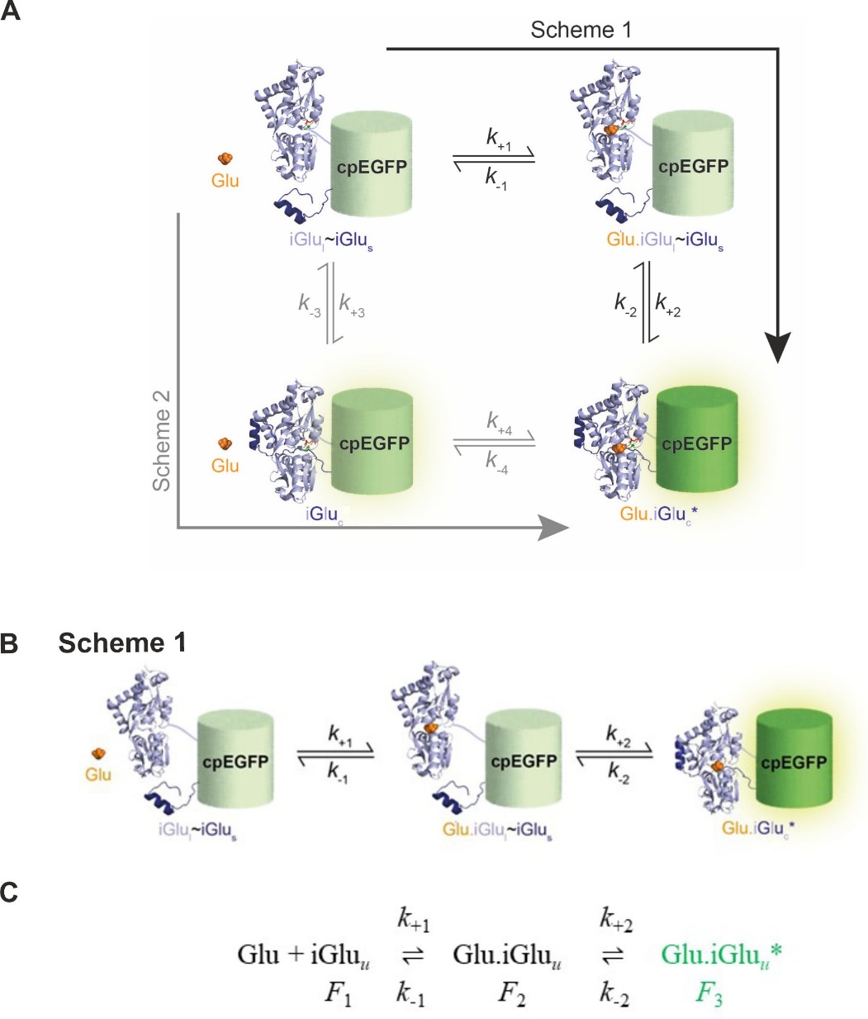

Figure 1. Alternative schemes for two-step protein-ligand interaction. (A) Kinetic paths of two-step mechanism involving ligand binding and isomerisation applied to iGluSnFR and its fast variants iGlu_{u} and iGlu_{f} (3). cpEGFP is flanked by a large fragment of GluBP, residues 1-253 (iGlu_{l}) (light blue ribbons) and a small fragment of residues 254-279 (iGlu_{s}) (dark blue ribbons) which reattach on glutamate binding to form the highly fluorescent iGlu complete (Glu.iGlu_{c}*) with the corrected structure of cpEGFP. (B) Cartoon representation of Scheme 1 depicting the kinetic mechanism of iGluSnFR and fast variants iGlu_{u} and iGlu_{f} (3). (C) Scheme 1 illustrated as a text equation using the example of ultrafast variant iGlu_{u} (3).

MATERIALS AND METHODS
Materials. pET41a iGlu_{m} (R24K), pET41a iGlu_{h} (E25A), pET41a iGlu_{l} (T92A) and pET30b GluBP were generated as previously described (3) and are available on ADDGENE (Watertown, MA) (119829, 119830, 119832 and 119835, respectively). Escherichia coli XL10-Gold and BL21(DE3) Gold cells were purchased from STRATAGENE (San Diego, CA). 6-Acryloyl-2-Dimethylaminonaphthalene (Acrylodan), 7-Diethylamino-3-(4'-maleimidylphenyl)-4-methylcoumarin (CPM), N-((2-(iodoacetoxy)ethyl)-N-Methyl)- amino-7-Nitrobenz-2-Oxa-1,3-Diazole (IANBD ester) and Oregon Green 488 maleimide were purchased from LIFE TECHNOLOGIES ltd (Paisley, UK) and 6-bromoacetyl-2-dimethylaminonaphthalene (BADAN) from EUROGENTEC (Southampton, UK). N-(2-(iodoacetamido)ethyl)-7-diethylaminocoumarin-3-carboxamide (IDCC) was a gift from J.E.T. Corrie, NIMR, London.
Site-directed mutagenesis. Ser or Thr to Cys mutations were introduced into pET30b GluBP via site-directed mutagenesis according to the QuikChange II XL protocol (AGILENT TECHNOLOGIES, Santa Clara, CA) using the following primers:
T71C 5’-GCAGGTAAAACTGATTCCGATTTGCTCACAAAACCGTATTCC-3’
S72C 5’- TAAAACTGATTCCGATTACCTGCCAAAACCGTATTCCACTGCTG-3’
T83C 5’-CCACTGCTGCAAAACGGCTGTTTCGATTTTGAATGTGGTTC-3’
S90C 5’- ACTTTCGATTTTGAATGTGGTTGTACCACCAACAACGTC-3’
T91C 5’- CGATTTTGAATGTGGTTCTTGCACCAACAACGTCGAACGC-3’
T92C 5’- GATTTTGAATGTGGTTCTACCTGCAACAACGTCGAACGCC -3’
T136C 5’-CAAAGCCGTAGTCGTCTGTTCCGGCACTACCTCTG-3’
S137C 5’-CGTAGTCGTCACTTGCGGCACTACCTCTGAAG-3’
T140C 5’-GTCGTCACTTCCGGCACTTGCTCTGAAGTTTTGCTCAAC-3’
A210C 5’- GCCGCAGTCTCAGGAGTGCTACGGTTGTATGTTG-3’
DNA sequences were verified by sequencing (GENEWIZ UK LTD, Bishop's Stortford, UK).
Protein expression and purification. iGluSnFR variants (iGlu_{l}, iGlu_{m} and iGlu_{h}) and GluBP proteins (GluBP and GluBP-T136C) were expressed and purified as previously described (3). Briefly, cells were grown at 37 °C until OD_{600nm} 0.5-1.0 and expression was induced with 0.4 mM IPTG, overnight at 20 °C. Cells were recovered by centrifugation and lysed by sonication on ice. Clarified lysates were purified by affinity purification (GSTrap or HisTrap, GE HEALTHCARE, Little Chalfont, UK) and purity was assessed by SDS-PAGE. Purified proteins were dialysed overnight at 4 °C in 50 mM HEPES-Na⁺, 200 mM NaCl pH 7.5 and stored at -80° C.
Protein labelling with thiol-reactive environmentally-sensitive fluorophores. Purified GluBP-T136C was labelled overnight at 4 °C using a 2-fold excess of fluorophore (Acrylodan, IDCC, CPM, Oregon Green 488 Maleimide, BADAN or IANBD). Labelled protein was then dialysed three times over a 24-hour period at 4 °C against 500 volumes of PBS to remove unreacted dye, then once against 300 volumes of assay buffer (50 mM HEPES-Na⁺ pH 7.5, 100 mM NaCl, 2 mM MgCl₂) for buffer exchange.
Measurement of protein concentration. Protein concentration was determined by UV spectroscopy. For GluBP T136C-IANBD (Fl-GluBP), an extinction coefficient of 25,000 M⁻¹ cm⁻¹ at 495 nm was used, which corresponds to the absorbance peak of IANBD ester. For the His-GluBP protein and iGluSnFR variants (iGlu_{h}, iGlu_{m} and iGlu_{l}) the extinction coefficients were and 24,075 M⁻¹ cm⁻¹ and 90,690 M⁻¹ cm⁻¹ respectively, at 280 nm (16).
Dynamic range and affinity measurements. Measurements were carried out using a Fluorolog3 spectrofluorimeter (HORIBA UK LTD, Northampton, UK). For dynamic range determination, fluorescence emission spectra were recorded in the presence and absence of ligand. F_{+ligand}/F_{-ligand} was calculated using values at the fluorescence emission maximum. For determination of ligand affinity and specificity (glutamate, aspartate, glutamine), ligand was added to the glutamate sensor (iGlu variant or labelled-GluBP) either manually or via continuous titration (10 µL/min) using an automated syringe pump (ALADDIN 1000, WPI, Hitchin, UK). Measurements were performed in a stirred 3 mL cuvette containing protein in assay buffer. For iGluSnFR variants λ_{ex} = 492 nm and λ_{em} = 512 nm, for Fl-GluBP λ_{ex} = 495 nm and λ_{em} = 535 nm was set. Data were corrected for dilution, normalised and the dissociation constant (K_{d}) and Hill coefficient (n, when appropriate) were determined by fitting the data using the ‘one site specific binding’ equation (with or without Hill slope as appropriate) in GraphPad Prism 7. Titrations were performed at least in triplicates and the error expressed as mean ± S.D.
Stopped-flow fluorimetry. Experiments were performed as detailed in (3) Helassa et al. (2018). Briefly, a KinetAsyst SF-61DX2 system (TGK SCIENTIFIC, Bradford on Avon, UK) equipped with a temperature manifold (17) was used to measure kinetics. Fluorescence excitation was set to 492 nm and fluorescence emission was collected using a long pass filter (>530 nm). For association kinetics, 0.25 – 0.7 µM protein (concentrations in the mixing chamber) was rapidly mixed with increasing concentrations of glutamate. For dissociation, GluBP was used in excess (915 – 1200 µM) and rapidly mixed with glutamate-bound sensor. η values were calculated for 3 °C using the density and viscosity calculator for glycerol/water mixtures based on Cheng (2008) at:
http://www.met.reading.ac.uk/~sws04cdw/viscosity_calc.html.
Data shown is the average of at least four traces, data was then fit using single or double exponentials (as appropriate) to ascertain the fluorescence rise or decay rate, using Kinetic Studio software (TgK SCIENTIFIC, Bradford on Avon, UK). The error quoted is the standard error of the fit.

RESULTS
The domain structure of genetically encoded iGluSnFR affinity variants termed iGlu-T92A (iGlu_{l}), iGlu-R24K (iGlu_{m}), iGlu-E25A (iGlu_{h}) and chemically labelled Fl-GluBP are depicted in Fig. 2A. Mutation sites for affinity variants and chemical labelling, respectively, were selected in the ligand binding site (Fig. 2B). Equilibrium titrations with glutamate revealed a broad range of affinities with K_{d}-s from μM to 10-s of mM and fluorescence enhancements upon glutamate binding between 1.7 and 2.9-fold (Fig. 3A and Table 1). The kinetic mechanisms of each of the four glutamate sensors will be presented in turn revealing three different kinetic pathways.
Figure 2
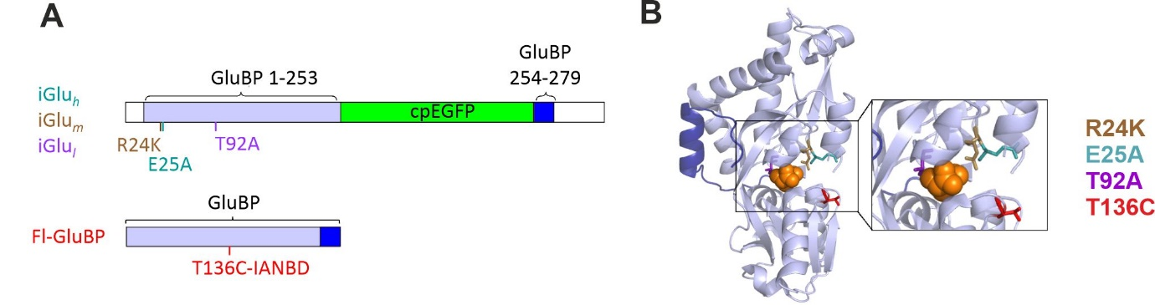

Figure 2. Design of iGluSnFR variants and Fl-GluBP. (A) Domain structure and labelling site. (B) Crystal structure of GluBP (PDB ID: 2VHA) with mutation sites indicated.

Kinetic mechanism of high affinity sensor iGlu-E25A (iGlu_{h}). Of the genetically encoded variants, iGlu-E25A (iGlu_{h}) had the highest affinity for glutamate (K_{d} of 5.8 ± 0.2 μM) with F_{(+Glu)}/F_{(-Glu)} of 3.4 ± 0.6 (Fig. 3A and Table 1). Association kinetic experiments in which 0.5 μM iGlu_{h} was rapidly mixed with glutamate at a series of concentrations showed a rapid rising phase of fluorescence followed by a second exponential fluorescence increase (Fig. 3B).
Figure 3
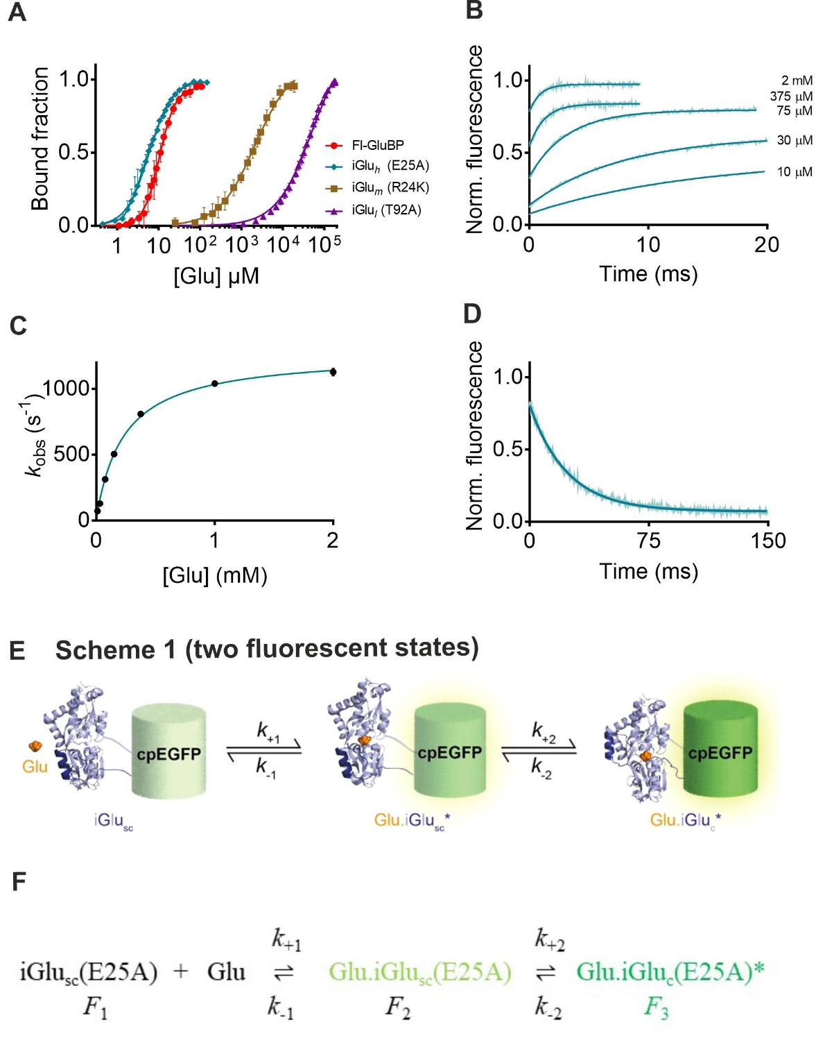

Figure 3. Equilibrium binding of novel sensors and kinetic mechanism of iGlu-E25A variant of iGluSnFR (iGlu_{h}). (A) Equilibrium titration with glutamate of iGlu variants and Fl-GluBP (20 °C). (B) Association kinetic records of iGlu-E25A (iGlu_{h}) (20 °C). 0.25 μM iGlu_{h} protein was rapidly mixed with different concentrations of glutamate. Solid lines are exponential fits to the data. (C) Plot of observed association rates (k_{obs}) against glutamate concentration for iGlu_{h} fitted to eq. 1. (D) Dissociation kinetics of iGlu_{h} (20 °C) fitted to a single exponential. (E) Cartoon representation and (F) illustration as a text equation of Scheme 1 (two fluorescent states) depicting the kinetic mechanism of iGlu_{h}. For the initially bound complex to develop fluorescence enhancement, an intermediate with ‘semi-complete’ (sc) structure iGlu_{sc}(E25A) is postulated, in which the separated GluBP fragments already have reattached. Glutamate binding to this gives Glu.iGlu_{sc}(E25A). A further structural rearrangement, possibly the closure of the cleft, then leads to the stable highly fluorescent complex Glu.iGlu_{c}(E25A)* (Glu.iGlu_{c}*).

The plot of the association rate of the second phase as a function of [Glu] had a hyperbolic appearance (Fig. 3C). In that, iGlu_{h} appears similar to iGluSnFR and fast variant iGlu_{f} (3). However, the important distinction is that iGluSnFR and fast variant iGlu_{f} had a low and a high fluorescence state, whereas iGlu_{h} presents two enhanced fluorescence states, the first developing in the initial rapid process and the second in a measurable exponential process. iGluSnFR and fast variant iGlu_{f} are represented by Scheme 1 above in which binding without fluorescence increase is followed by isomerisation in which fluorescence enhancement occurs. The mechanism for iGlu_{h} is depicted in Scheme 1 (two fluorescent states), in which rapid binding of glutamate is also followed by a conformational change, however both binding and isomerisation induce separate fluorescence enhancements the latter stabilising the initially bound complex. For the initially bound complex to develop fluorescence enhancement, an intermediate with ‘semi-complete’ (sc) structure iGlu_{sc}(E25A) is thus postulated, in which the separated GluBP fragments already have reattached. Glutamate binding to this gives Glu.iGlu_{sc}(E25A). A further structural rearrangement, possibly the closure of the cleft, then leads to the stable highly fluorescent complex Glu.iGlu_{c}(E25A)* (Scheme 1 (two fluorescent states)). Fluorescence enhancement in each phase is thought to be based on a shift of the equilibrium between the protonated, low fluorescence form (with absorption maximum of 400 nm) and the deprotonated, high fluorescence form that absorbs at 492 nm (18). Thus, increased brightness is expected to be based on the increase of the ε_{o(492 nm)} as found for iGluSnFR and fast variants iGlu_{u} and iGlu_{f} (3).
Dissociation kinetics were measured by trapping released glutamate from the complex of iGlu_{h} with glutamate with > 100-fold excess of purified GluBP (see Materials and Methods). Single exponential decay with a dissociation rate constant of 42.4 ± 0.2 s⁻¹ (20 °C) was measured (Fig. 3.D). Glutamate association kinetics would be described by k_{obs1} = k₊₁ [Glu] + k₋₁ in pseudo-first order conditions, here these were too fast to measure. Observed rates (k_{obs2}) obtained for the isomerisation step were plotted as a function of [Glu]. A hyperbolic association rate plot was obtained which was fitted to eq. 1 (19). For detailed derivation of eq. 1 also see SI in (3). The value for k₋₂ was fixed at the measured value of 42 s⁻¹. Best fit parameters were (3.92 ± 0.33) x 10³ M⁻¹ for K₁ and 1243 ± 32 s⁻¹ for k₊₂, indicating strong stabilisation in the isomerisation step. These parameters give a K_{d(overall)} of 8.4 μM, which is within a two-fold range of the 5.8 ± 0.2 μM measured by equilibrium titration.

k_{obs2} = k₊₂ K₁ [Glu]/(1 + K₁ [Glu]) + k₋₂ eq. 1

To estimate the order of magnitude of k₊₁, the set of association kinetic records were subjected to global fitting, using k₊₂ 1243 s⁻¹ and k₋₂ 42 s⁻¹ form the hyperbolic fit, and with K_{d(overall)} as a constraint. Global fitting indicated that values for k₊₁ < 10⁸ M⁻¹s⁻¹ were insufficient to reproduce the rapid initial fluorescence increase. Using k₊₁ of 2.1 x 10⁸ M⁻¹s⁻¹ and k₋₁ of 53500 s⁻¹ (corresponding to K₁ 3.87 x 10³ M⁻¹, a value close to 3.92 x 10³ M⁻¹ obtained from the fit to the hyperbole in Fig. 3C), the fitted curves satisfactorily reproduced the data (see SI). From the parameters of the global fit the calculated K_{d(overall)} was 8.4 μM. The high association rate constant indicated rapid, diffusion limited glutamate binding to iGlu_{sc}(E25A). The strongly shifted equilibrium to Glu.iGlu_{c}(E25A)* is consistent with the observed single exponential dissociation kinetics.

Kinetic mechanism of low affinity sensor iGlu-T92A (iGlu_{l}). iGlu-T92A (iGlu_{l}) had the lowest affinity (K_{d} of 50 ± 2 mM) with glutamate induced fluorescence enhancement F_{(+Glu)}/F_{(-Glu)} of 1.7 ± 0.5 (Fig. 3A and Table 1). The fluorescence enhancement of iGlu-T92A (iGlu_{l}), similarly to iGlu_{h} above, also showed biphasic kinetics: a fast fluorescence increase with rates too fast to measure, followed by a single exponential fluorescence rise on glutamate binding with observed rates of up to 1200 s⁻¹ (Fig. 4A,B). However, the observed association rate, k_{obs2} decreased as [glutamate] increased, plateauing at 400 s⁻¹. Such pattern of the association rate plot is consistent with a mechanism in which a slow pre-equilibrium exists between two forms of the apo-protein, when glutamate binds to one of them preferentially (Scheme 2) (20). In the case of iGlu_{l}, two apo-forms iGlu_{l}-iGlu_{s}(T92A) and iGlu_{c}(T92A), which has an elevated fluorescence intensity, are in equilibrium. Glutamate preferentially binds to iGlu_{c}(T92A) resulting in a further fluorescence enhancement.
The association rate plot in Fig.4B was fitted to eq. 2, which represents the analytical solution for Scheme 2 (20). Best fit values to the data were k₊₃ of 361 ± 670 s⁻¹, k₋₃ of 739 ± 518 s⁻ ¹ and K_{d4} of 86 ± 212 mM (R² of 0.71) giving a K_{d(overall)} of 28 mM (the measured value was 50 ± 2 mM). Using parameters close to the mean values (k₊₃ of 400 s⁻¹ and k₋₃ of 800 s⁻ ¹) for global fitting of the association kinetic data, k₊₄ of 2 x 10⁶ M⁻¹s⁻¹ and k₋₄ of 85000 s⁻¹ were obtained (see SI). Dissociation kinetics were not possible to measure for iGlu_{l} given the combination of its low affinity and fluorescence dynamic range.

Figure 4
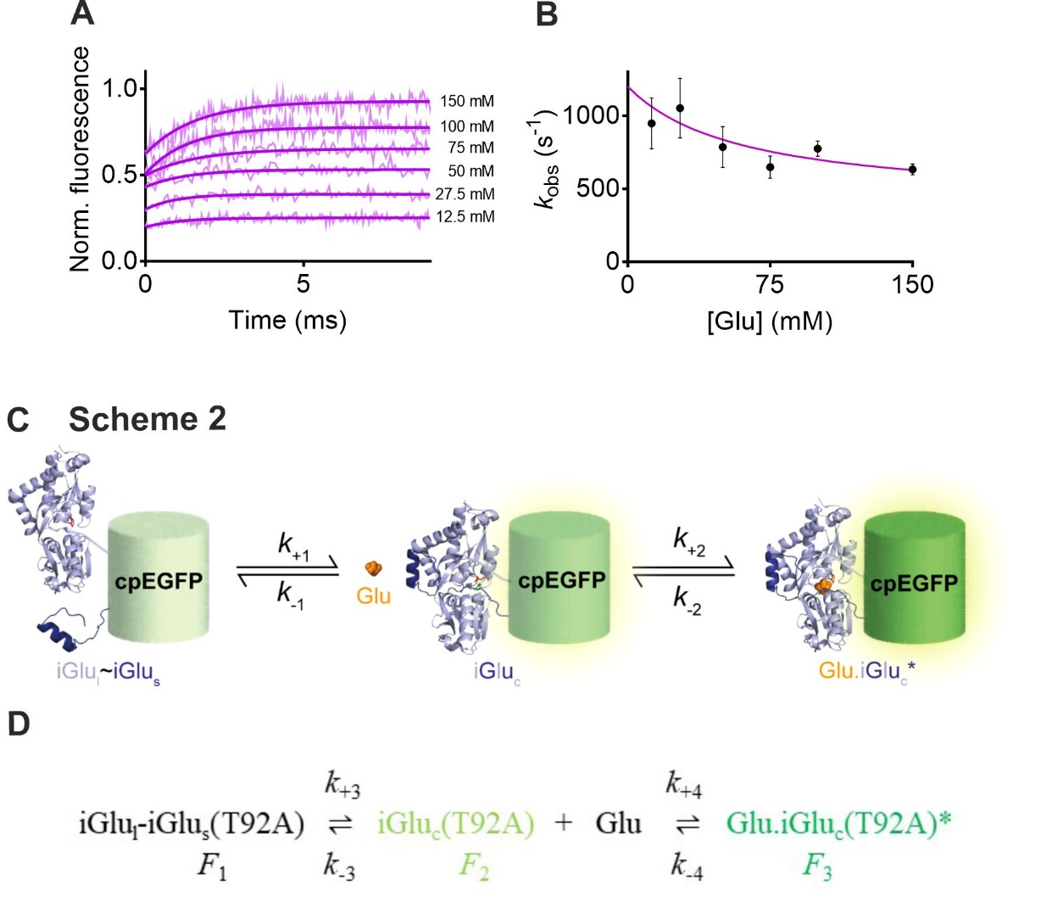

Figure 4. Kinetic mechanism of iGlu-T92A (iGlu_{l}). (A) Association kinetic records of iGlu-T92A (iGlu_{l}) (20 °C). 0.7 μM iGlu_{l} protein was rapidly mixed with different concentrations of glutamate. Solid lines represent exponential fits to the data. (B) Plot of observed association rates (k_{obs}) against glutamate concentration for iGlu_{l}. The solid line represents the fit to eq. 3. (C) Cartoon representation and (D) illustration as a text equation of Scheme 2 for iGlu_{l}.

k_{obs2} = k₊₃ + k₋₃ K_{d4}/(K_{d4} + [Glu]) eq. 2

Kinetic mechanism of medium affinity sensor iGlu-R24K (iGlu_{m}). iGlu-R24K (iGlu_{m}) is a medium affinity probe (K_{d} of 2.1 ± 0.1 mM) with F_{(+Glu)}/F_{(-Glu)} of 2.5 ± 0.4 (Fig. 3A and Table 1). Like iGlu-T92A (iGlu_{l}), iGlu-R24K (iGlu_{m}) showed biphasic kinetics: a fast fluorescence increase with rates too fast to measure was followed by a single exponential fluorescence rise on glutamate binding with observed rates of up to 675 s⁻¹ (Fig. 5A,B). The observed association rate, k_{obs2} decreased as [glutamate] was increased, plateauing at 350 s⁻¹. Such pattern of the association rate plot is consistent with a mechanism in which a slow pre-equilibrium exists between two forms of the apo-protein, when glutamate binds to one of them preferentially (Scheme 2). For of iGlu_{m}, iGlu_{l}-iGlu_{s}(R24K) and iGlu_{c}(R24K) are in equilibrium, glutamate binds to iGlu_{c}(R24K) preferentially. iGlu_{c}(R24K) has greater fluorescence intensity than iGlu_{l}-iGlu_{s}(R24K) and glutamate binding results in a further fluorescence enhancement. Dissociation kinetics were measured by trapping released glutamate from the complex of Glu_{m} with glutamate with > 100-fold excess of purified GluBP (see Materials and Methods). A single exponential fluorescence decay was obtained for Glu_{m} with a rate of 365 ± 58 s⁻¹ (20 °C) (Fig. 5C). The lack of an initial fast phase and the only a partial fluorescence decrease in the dissociation record indicated that significant rebinding of glutamate occurred in the conditions used. The association rate plot data were fitted to Eq. 2 (20), gave the following set of parameters for Glu_{m}: K_{d4}, 2.3 ± 13.1 mM; k₊₃, 436 ± 146 s⁻¹and k₋₃, 238 ± 357 s⁻¹ (R² 0.72). The K_{d(overall)} calculated from the fitted values is 1.5 mM, which is in good agreement with the measured value of 2.1 ± 0.1 mM. Global fit gave k₊₄, 6 x 10⁶M⁻¹s⁻¹ and k₋₄, 18000 s ⁻¹, resulting in K₄ of 3 mM and K_{d(overall)} of 1.1 mM (see SI).
As illustrated in Fig. 1 above, Scheme 1 and Scheme 2 represent two pathways leading to the same final product. In the case of iGlu_{m}, the variation of association k_{obs} is relatively minor and the trend can be taken as concentration independent. The mean value of the observed rates k₊₂ + k₋₂ is 507 s⁻¹. Global fitting of the data to Scheme 1 (two fluorescent states) results in a similarly good fit with k₊₁ of 4 x 10⁶ M⁻¹s⁻¹, k₋₁ of 16000 s⁻¹, k₊₂ 135 and k₋₂ of 365 s⁻¹, giving Kd_{(overall)} of 2.9 mM. Thus, for iGlu_{m}, it is not possible to distinguish between the kinetic paths taken.
Figure 5
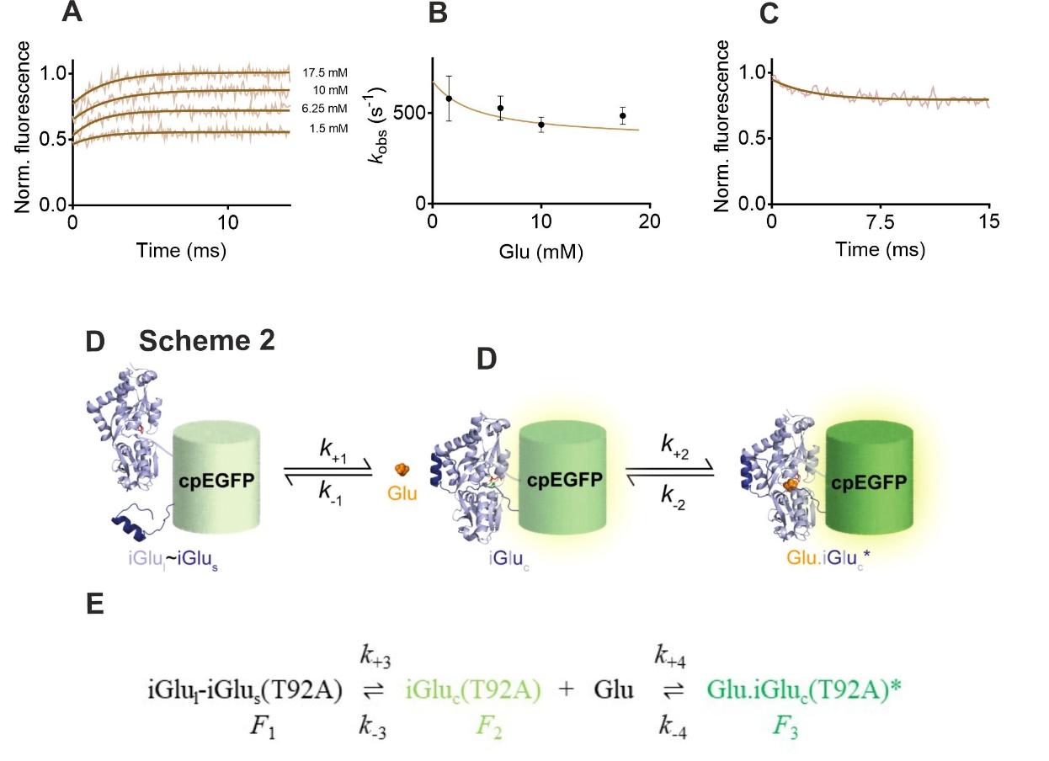

Figure 5. Kinetic mechanism of iGlu-R24K (iGlu_{m}). (A) Association kinetic records of iGlu-R24K (iGlu_{m}) (20 °C). 0.5 μM iGlu_{m} protein was rapidly mixed with different concentrations of glutamate. Solid lines represent exponential fits to the data. (B) Plot of observed association rates (k_{obs}) against glutamate concentration for iGlu_{m}. (C) Dissociation kinetics of iGlu_{m} (20 °C). (D) Cartoon representation and (E) illustration as a text equation of Scheme 2 for iGlu_{m}.

Development and kinetic mechanism of Fl-GluBP. GluBP variants T71C, S72C, T83C, S90C, T92C, T136C, S137C, T140C and A210C were generated and covalently labelled with environmentally sensitive fluorophores acrylodan, BADAN, CPM, IDCC, IANBD ester and Oregon Green 488 maleimide (Fig. 6). Fluorescently labelled derivatives were tested for fluorescence dynamic range, ligand selectivity and kinetic response to ligand binding. Of all the combinations tested, IANBD-GluBP-T136C (termed Fl-GluBP) stood out with a 2.9-fold fluorescence enhancement upon glutamate binding, none of the other combinations yielded greater than 10 % fluorescence change. The K_{d} of Fl-GluBP for glutamate was 9.7 ± 0.3 μM (Fig. 3A and Table 1), at physiological ionic strength, pH 7.5 and 20 °C, ~20-fold increased from the 600 nM reported for GluBP (21).

Figure 6
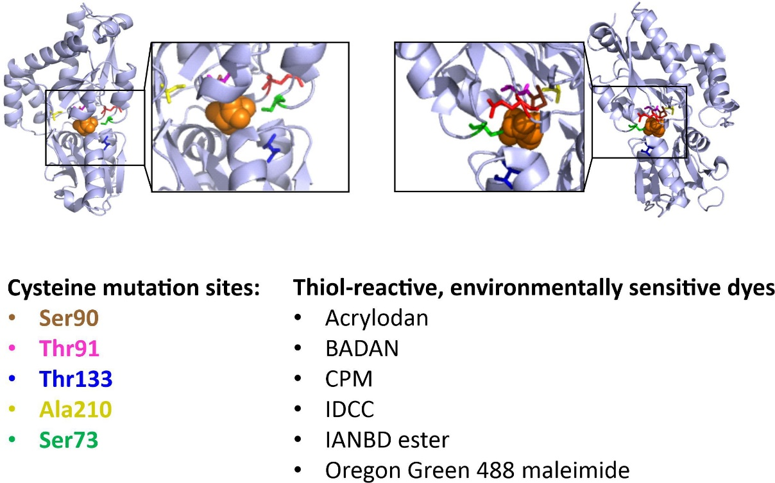
Figure 6. Mutation sites and fluorophores in the design of chemically labelled fluorescent glutamate sensor.

The kinetics of the interaction of Fl-GluBP with glutamate were investigated by fluorescence stopped-flow at 3 °C (Fig. 7A). Phenomenologically a kinetically similar mechanism to that in Scheme 1 (two fluorescent states) was observed for a novel chemically labelled glutamate sensor, Fl-GluBP; however, the mechanism of fluorescence enhancement is different, based on polarity change around the synthetic fluorophore. The scheme depicting Fl-GluBP kinetic mechanism is thus termed Scheme 1 (synthetic).
For association kinetic experiments, as the glutamate concentration increased, it became apparent that the measured single exponential rise is preceded by a jump to a level that represents most of the fluorescence increase, indicating that at saturating concentrations, the first phase of the interaction - ~ 90% of the fluorescence enhancement - was too fast to measure. Rates in the range of 200 to 800 s⁻¹, showing saturation, were measured for the second phase, interpreted as an isomerisation. Plotting the isomerisation rate (k_{obs}) as a function of glutamate concentration, a hyperbolic concentration dependence was observed (Fig. 7B). Dissociation kinetics were obtained by rapidly mixing saturated 0.5 µM Fl-GluBP (33 μM glutamate) with 457 μM GluBP. A single exponential fluorescence decay at a rate of 217 ± 5 s⁻¹ was observed at 3 °C (Fig. 7C), extrapolated to 1003 s⁻¹ at 37 °C based on a linear Arrhenius plot (Fig. 7C inset).
The kinetic data measured at 3 °C for Fl-GluBP were interpreted in terms of a two-step mechanism in which rapid glutamate binding is followed by isomerisation (Scheme 1 synthetic). Best fit parameters to the hyperbole in Fig. 7B were: K₁’ of 6957 ± 131 M⁻¹, k’₊₂ of 1128 ± 137 s⁻¹ and k’₋₂ of 230 s⁻¹ (fixed constant) giving K_{d(overall)} 24 μM, comparable to the measured 9.7 ± 0.3 μM (Fig. 3A and Table 1). To obtain a good global fit to the association kinetic record set a k’₊₁ of greater or equal to 10⁹ M⁻¹s⁻¹ was required, indicating diffusion-limited glutamate binding. Further parameter values obtained from the global fit were: k’₋₁ of 216000 s⁻¹, k’₊₂ of 2220 s⁻¹ and k’₋₂ of 230 s⁻¹ (K_{d(overall)} 20.2 μM).

Figure 7
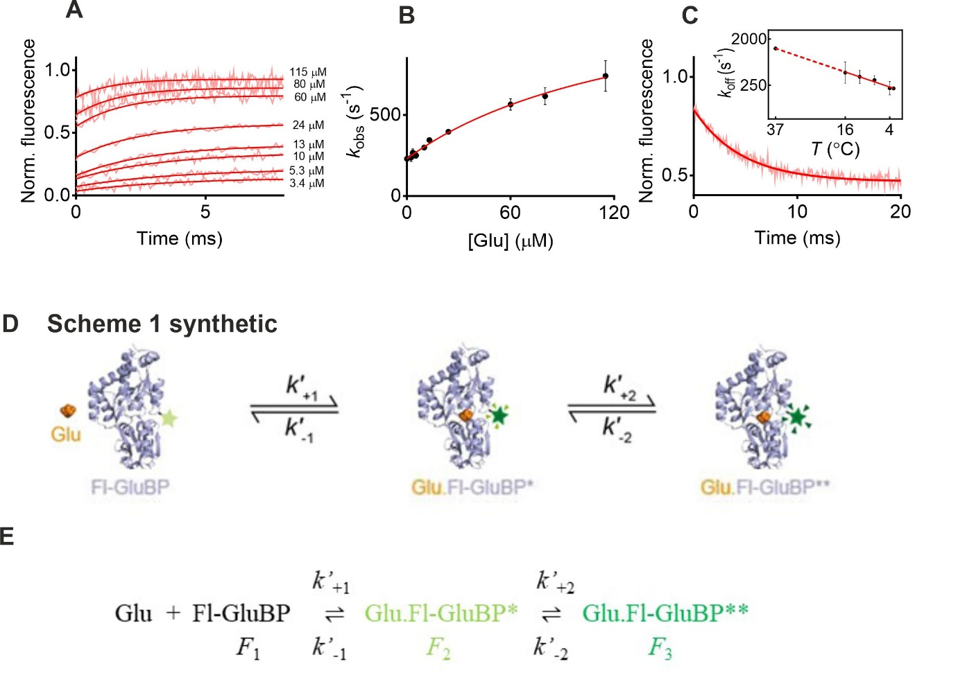
Figure 7. Kinetic mechanism of Fl-GluBP. (A) Association kinetic records of Fl-GluBP (3 °C). 0.5 μM Fl-GluBP protein was rapidly mixed with different concentrations of glutamate. Solid lines are exponential fits to the data. (B) Plot of observed association rates (k_{obs}) against glutamate concentration for Fl-GluBP. (C) Dissociation kinetics of Fl-GluBP (3 °C). Inset: Arrhenius plot of temperature dependence of the off-rate. (D) Cartoon representation and (E) illustration as a text equation of Scheme 1 synthetic for Fl-GluBP.

Kinetics of glutamate binding to Fl-GluBP under increased viscosity. We measured the association kinetics of Fl-GluBP at increasing solvent viscosities to see if the diffusion-limited glutamate binding step is affected. Relative viscosity (η) was increased up to 6-fold. Interestingly, the amplitude of fluorescence enhancement rather than the rate of binding was affected. Holding [glutamate] at 50 μM (in the mixing chamber), the rapid binding step appeared as a progressively smaller ‘jump’ in fluorescence intensity, and was completely abolished in 60% glycerol (Fig. 8A). The disappearance of the initial fast fluorescence was the result of the apo-state fluorescence intensity increasing with greater viscosity. Increasing solvent viscosity thus had a similar effect on the fluorescence intensity of apo-Fl-GluBP to glutamate binding. At relative viscosity η of 6, the glutamate binding invoked fluorescence increase purely reflected the conformational change of the protein.
In contrast, the rate of isomerisation was slowed down from 600 s⁻¹ to 400 s⁻¹ at 50-60% glycerol (Fig. 8B). Applying a previously developed theory (22) from the foundation laid down in (23) for the effect of solvent viscosity on first order processes, we obtained a good fit for our isomerisation data to eq. 3, where C and σ ( σ has units of viscosity) are adjustable parameters, η is solvent viscosity. The pattern of the rate plot fits well to the theory that, in the viscosity range examined, both internal friction of the protein and friction of the molecule with the solvent contribute to decreasing the rate constant (22) (Fig. 8B). The fitted values gave C = 1.96 x 10⁸ cP.s⁻¹, σ = 40.45 cP and E_{o} = 4.87 kcal.mol⁻¹. The small activation energy indicates that most of the change in the rate constant is due to the change in viscosity (22).
k_{obs} = C*exp(-E_{o}/RT)/(σ+η) eq. 3
Ligand selectivity of iGlu_{l}, iGlu_{m}, iGlu_{h} and Fl-GluBP. Each of the mutations giving iGlu_{l}, iGlu_{m}, iGlu_{h} shifted the selectivity towards aspartate which does not disqualify these variants from investigations at excitatory synapses in the hippocampus where glutamate fully accounts for neurotransmission (24). The selectivity for glutamate over glutamine is a more complex issue. The lowest affinity variants iGlu_{l} and iGlu_{m} appear to show the highest selectivity for glutamate, their response to glutamine is hardly detectable. Fl-GluBP is highly selective for glutamate (K_{d} 10.6 ± 2.3 μM) over aspartate (K_{d} 184 ± 15 μM) and glutamine (K_{d} 896 ± 55 μM), as well as with smaller, 1.7 and 2.5-fold fluorescence enhancements, respectively (Fig. 8F and Table 2). However, in an environment where both glutamate and glutamine are present, iGlu_{h} and Fl-GluBP could yield composite signals due to their affinities being relevant to the physiological concentration ranges and high fluorescence dynamic range for both ligands (Fig 8D,E and Table 2). At 100 μM glutamate for example, Fl-GluBP would be saturated by while giving only 10% of the signal at 100 μM glutamine. However, Fl-GluBP would function well in the synaptic cleft where glutamine concentration is negligible. Fl-GluBP may also be suitable for detecting glutamine in an environment where glutamate concentration is negligible. D-Ser, glycine and GABA do not evoke any fluorescence response from Fl-GluBP (data not shown).
Figure 8
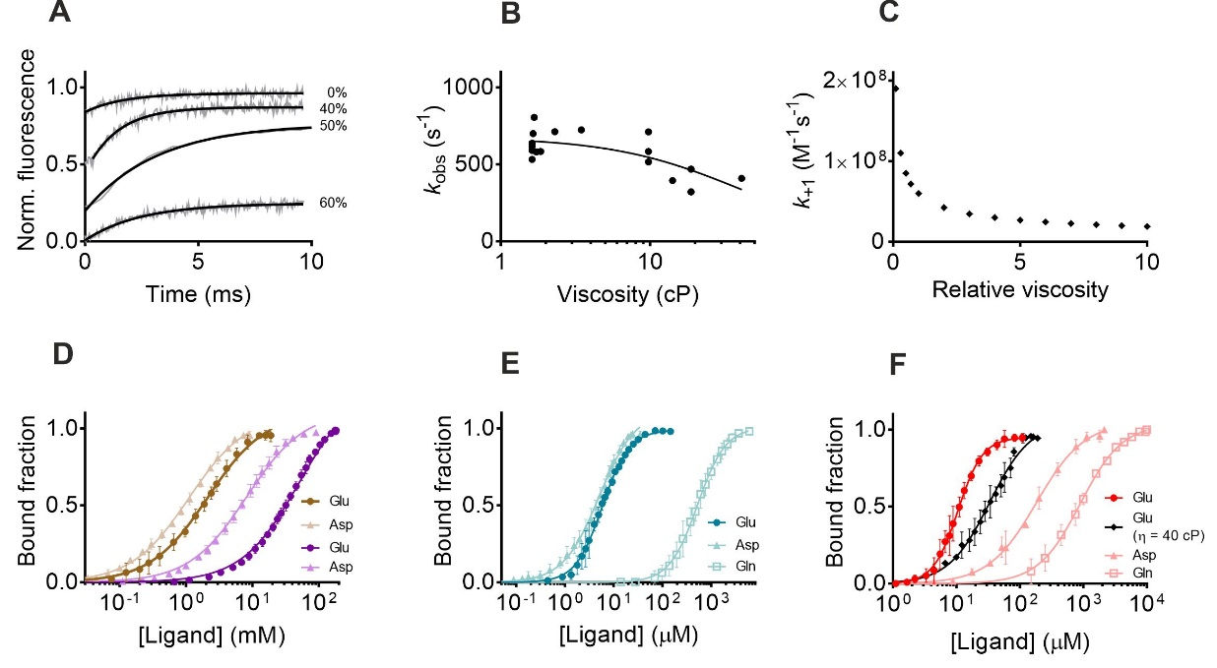
Figure 8. Viscosity dependence and selectivity. (A) Association kinetic records for Fl-GluBP in solvents with increasing viscosity at 3 °C. (B) Plot of observed rates (k_{obs}) against relative viscosity for Fl-GluBP. Measured values were fitted to eq. 3 (solid line). (C) Plot of predicted second order rate constant as a function of relative viscosity, at 3 °C. (D) Equilibrium titration of iGlu-T92A (iGlu_{l}) (purple symbols and lines) and iGlu-R24K (iGlu_{m}) (terracotta symbols and lines) with glutamate and aspartate at 20 °C. (E) Equilibrium titration of iGlu-E25A (iGlu_{h}) with glutamate, aspartate and glutamine at 20 °C. (F) Equilibrium titration of Fl-GluBP with glutamate (in 0 and 60% glycerol) at 3 °C, aspartate and glutamine at 20 °C.

DISCUSSION
Protein-based fluorescent glutamate sensors have the potential for real-time monitoring of synaptic and cellular glutamate concentration changes. We have developed both genetically encoded and chemically labelled fluorescent glutamate sensors and characterised the kinetic mechanisms of their glutamate sensing. Previously described iGlu_{f} and iGlu_{u} responded to glutamate binding with a single exponential fluorescence increase which occurred in an isomerisation step following glutamate binding (Scheme 1) (3). Novel variants, iGlu_{l} and iGlu_{m} with mM affinity for glutamate, follow an alternative kinetic path whereby reattachment of GluBP fragments, accounting for part of the fluorescence enhancement, is required for glutamate to bind to the reformed complex, which causes further fluorescence enhancement (Scheme 2). For iGlu_{l} and iGlu_{m} the conformer with the separate large and small GluBP fragments is in an equilibrium with the reassembled, ‘complete’ GluBP (a low-fluorescence conformer) to which glutamate preferentially binds followed by most of the fluorescence enhancement. It is likely that the binding is followed by an ‘open-to-closed transition and the two are seen in combination in the rapid fluorescence rise. It must be noted that with the exception of iGlu_{l} and iGlu_{m}, equilibrium titration curves are best fit to the Hill equation giving Hill coefficient (n) values of 1.6 to 2.3. However, as the kinetic analyses reveal, none of the kinetic data indicate cooperativity of binding. Therefore, n = 1 is used in the kinetic analyses.
Glutamate binding to iGlu_{h,} is followed by isomerisation (Scheme 1 (two fluorescent states)). Fluorescence enhancement of iGlu_{h} is biphasic with most of the increase occurring in the diffusion limited glutamate binding phase, indicating that apo-GluBP in this variant exists in a ‘semi-complete’ conformation in which the small fragment may already be attached to the large fragment albeit not in a stable conformation. iGlu_{m} isomerisation showed a shallow concentration dependence in the association kinetics. These data are compatible with either Scheme 2 or Scheme 1 (two fluorescent states).
Fl-GluBP, a glutamate sensor generated by fluorescent derivatisation of GluBP with a synthetic fluorophore also yields most of its fluorescence enhancement in the initial glutamate binding phase which occurs with a diffusion limited rate constant (Scheme 1 synthetic). A subsequent isomerisation further stabilises the fluorescent complex. The rate of isomerisation for Fl-GluBP is fitted to saturate at 2220 s⁻¹ at 3 °C, indicating that Fl-GluBP will be suitable as a real-time tracker of synaptic glutamate transients.
While we were therefore unable to measure the second order rate constant (k₊₁) for glutamate binding even at increased solvent viscosity, we attempt to estimate it. An inverse relationship between rate constant and viscosity has been reported (25). Reasoning, that for it to be too fast to measure at 3 °C and have a relative viscosity of 6 at 50 μM glutamate, the observed association rate needs to be > 1000 s⁻¹, k₊₁ > 2 x 10⁷ M⁻¹s⁻¹ is required. At relative viscosity of 1, k₊₁ is predicted to be 10-fold higher, > 2 x 10⁸ M⁻¹s⁻¹ at 3 °C (Fig. 8C). Assuming a 2-fold increase for every 5 °C increase in temperature, k₊₁ > 2 x 10⁹ M⁻¹s⁻¹ at 20 °C and k₊₁ > 3 x 10¹⁰ M⁻¹s⁻¹ 37 °C are predicted. If another empirical formula in which there is an inverse relationship between diffusion-controlled reaction rate constant and the square root of relative viscosity is used (26), the estimates are in the same range. These values are consistent with diffusion limited glutamate association kinetics which makes Fl-GluBP and iGlu_{h} potential real-time detectors of synaptic glutamate release kinetics.
There is strong structural homology between GluBP and the S1S2 glutamate binding domain of AMPAR (Fig.9). Neither iGluSnFR-type probes, nor the previously studied Trp fluorescence changes allowed the observation of glutamate binding itself. The observed conformational changes by Trp fluorescence led to the Venus fly-trap model for ligand binding to bacterial periplasmic binding proteins (14,27) and the homologous S1S2 glutamate binding construct derived from AMPAR (15) which does not explain the rapid opening of the AMPAR ion channel triggered by ligand glutamate binding. Neither can the iGlu_{u} fluorescence response, which is based on a protein conformational change (3). The kinetic examination of Fl-GluBP and iGlu_{h}, however, reveals that they signal diffusion limited binding of glutamate. We propose that a similar mechanism of diffusion-limited glutamate binding exists for and forms the basis of rapid gating of AMPAR.
Figure 9
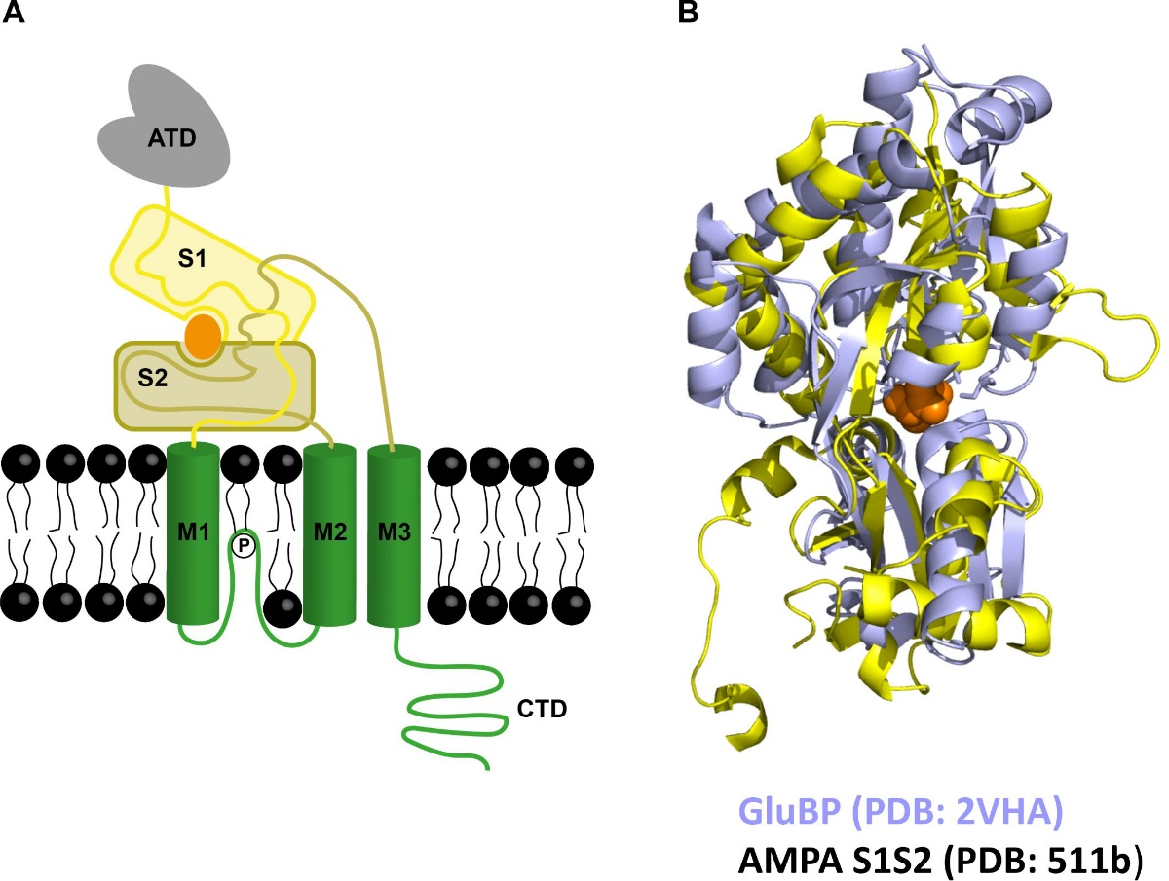
Figure 9. Structural alignment of AMPAR S1S2 glutamate binding domain and bacterial glutamate/aspartate binding protein. (A) Schematic structure of AMPAR, illustrating the glutamate binding domain (S1S2). (B) The structures of GluBP and AMPAR S1S2 are aligned using Pymol software to reveal a high degree of structural homology.

Moreover, a fluorescent sensor like Fl-GluBP may be useful for measuring synaptic viscosity. This may be through the relative fluorescence measurements of the binding and isomerisation steps or by lifetime imaging as the lifetime is expected to increase if a singlet‐exciplex intermediate is formed (28,29).
The two low-affinity glutamate sensors iGlu_{l} and iGlu_{m} have fast off-rates of 800 s⁻¹ (fitted value) and 365 s⁻¹ (measured at 20 °C), respectively. The off-rate for Fl-GluBP is measured as 217 s⁻¹ at 3 °C, the extrapolated value at 37 °C is 2000 s⁻¹, from its Arrhenius plot. All three sensors would thus allow monitoring processes on the sub-millisecond time scale, at the temperatures of physiological experiments (34 - 37 °C). Through their broad affinity range and mechanistic variety, the above genetically encoded and chemically labelled fluorescent glutamate sensors could form part of a toolkit designed for monitoring the different processes that glutamate undergoes in neurotransmission and cellular homeostasis. Each variant would be best suited to indicate glutamate concentration changes in the range of their affinity.
The stopped-flow association kinetic data reveal how each sensor would respond when glutamate is elevated. For example, the response rate of Fl-GluBP response near-proportionately increases with [Glu] in the 10-s of μM range. iGlu_{h}, up to ~0.2 mM [Glu] gives slow, concentration dependent fluorescence responses the rate and amplitude of which increases proportionately with [Glu] rate is, limited by the ligand binding rate. Above ~ 1 mM, the isomerisation is rate limiting, thus the response is concentration independent saturating the probe. With iGlu_{l}, there is relatively little concentration dependence of the on-kinetics, but the response amplitude increases through the tens of mM range.
Relative fluorescence, molecular brightness values for the intermediates were derived from the fold increase on glutamate binding, taking into account the isomerisation equilibrium and estimation of F₂ from the association kinetic records, to calculate F₃. These values, together with the full set of rate constants allow simulation of the response (see SI). Moreover, applying the observed rates at particular glutamate concentration would allow calculation of the ratio of the amplitudes from which the concentration of intermediates can be deduced (30).
In summary, this work reveals previously unseen kinetic properties and the kinetic mechanisms of fluorescent glutamate probes based on the bacterial periplasmic glutamate/aspartate binding protein. This family of ligand binding proteins has previously been described by the Venus flytrap mechanism in which slow binding is followed by rapid closure of the binding cleft. This was based on observing the fluorescence response of Trp residues which evidently only reported the conformational change following binding. Here we discovered that GluBP and a high affinity variant bind glutamate with a diffusion limited rate constant We further postulate that given the strong structural homology with the AMPAR binding domain, initial glutamate binding limited by diffusion, collision is sufficient to trigger the rapid change in the environment of the fluorophore, which is the binding site, for channel opening of the AMPAR which occurs within tens of microseconds, and for which the subsequent conformational change (domain closure?) is not required. Our data furthermore highlight the kinetic diversity that arises from single residue mutations around the binding pocket.

CONCLUSION
Subtle structural changes brought about by single amino acid substitutions, in addition to affecting their ligand binding affinity and selectivity, also redirect the kinetic paths of the fluorescence response of iGluSnFR variants. A novel probe labelled with synthetic fluorophore reveals diffusion limited glutamate binding, hints at the AMPAR response mechanism and may be suitable for measuring synaptic viscosity.

Author Contributions. C.C. and S.K generated the genetically encoded proteins, performed experiments, analysed data and generated figures; N.H. generated the chemically labelled probes. K.T. designed the project and wrote the paper.

Acknowledgements. This work was funded by Wellcome Trust grant 094385/Z/10/Z and BBSRC grants BB/M02556X/1 and BB/S003894/1 to K.T. Dr Alamin Mohammed is thanked for comments on the manuscript. Melissa Matthews is thanked for her help with the characterisation of the R24K iGluSnFR variant.

REFERENCES
1. Marvin, J. S., Borghuis, B. G., Tian, L., Cichon, J., Harnett, M. T., Akerboom, J., Gordus, A., Renninger, S. L., Chen, T. W., Bargmann, C. I., Orger, M. B., Schreiter, E. R., Demb, J. B., Gan, W. B, Hires, S. A., and Looger, L. L. 2013 An optimized fluorescent probe for visualizing glutamate neurotransmission. Nat. Methods 10:162-170.
2. Marvin, J. S., Scholl, B., Wilson, D. E., Podgorski, K., Kazemipour, A., Müller, J. A., Schoch, S., Quiroz, F. J. U., Rebola, N., Bao, H., Little, J. P., Tkachuk, A. N., Cai, E., Hantman, A. W., Wang, S. S., DePiero V. J., Borghuis, B. G., Chapman, E. R., Dietrich, D., DiGregorio, D. A., Fitzpatrick, D., and Looger, L. L. 2018 Stability, affinity, and chromatic variants of the glutamate sensor iGluSnFR. Nat. Methods. 15:936-939.
3. Helassa, N., Dürst, C. D., Coates, C., Kerruth, S., Arif, U., Schulze, C., Wiegert, J. S., Geeves, M., Oertner, T. G., and Török, K. 2018 Ultrafast glutamate sensors resolve high-frequency release at Schaffer collateral synapses. Proc. Natl. Acad. Sci. U. S. A. 115:5594-5599.
4. Dvorzhak, A., Helassa, N., Török, K., Schmitz, D., and Grantyn, R. 2019 Single synapse indicators of impaired glutamate clearance derived from fast iGlu_{u} imaging of cortical afferents in the striatum of normal and 2 Huntington (Q175) mice. J. Neurosci. Feb 28. pii: 2865-18. doi: 10.1523/JNEUROSCI.2865-18.2019. [Epub ahead of print]
5. Li, G., Pei, W., and Niu, L. 2003 Channel-opening kinetics of GluR2Q(flip) AMPA receptor: a laser-pulse photolysis study. Biochemistry 42:12358-12366.
6. Scimemi, A., and Beato, M. 2009 Determining the neurotransmitter concentration profile at active synapses. Mol. Neurobiol. 40:289-306.
7. Zheng, K., Jensen, T. P., Savtchenko, L. P., Levitt, J. A., Suhling, K., and Rusakov, D. A. 2017 Nanoscale diffusion in the synaptic cleft and beyond measured with time-resolved fluorescence anisotropy imaging. Sci. Rep. 7:42022.
8. Best, S. L., Corrie, J. E. T., and Török, K. 2005 Development of a fluorescent glutamate binding protein. Biophys. J. 88:46a-47a.
9. Namiki, S., Sakamoto, H., Iinuma, S., Iino, M., and Hirose, K. 2007 Optical glutamate sensor for spatiotemporal analysis of synaptic transmission. Eur. J. Neurosci. 25:2249-2259.
10. Takikawa, K., Asanuma, D., Namiki, S., Sakamoto, H., Ariyoshi, T., Kimpara, N., and Hirose, K. 2014 High-throughput development of a hybrid-type fluorescent glutamate sensor for analysis of synaptic transmission. Angew. Chem. Int. Ed. Engl. 53:13439-13443.
11. Solscheid, C., Kunzelmann, S., Davis, C. T, Hunter, J. L, Nofer, A., and Webb, M. R 2015 Development of a Reagentless Biosensor for Inorganic Phosphate, Applicable over a Wide Concentration Range. Biochemistry 54:5054-5062.
12. de Lorimier, R. M., Smith, J. J., Dwyer, M. A., Looger, L. L., Sali, K. M., Paavola, C. D., Rizk, S. S., Sadigov, S., Conrad, D.W, Loew, L., and Hellinga, H. W. 2002 Construction of a fluorescent biosensor family. Protein Sci. 11:2655-2675.
13. Kunzelmann, S., Solscheid, C., and Webb, M. R. (2014) Fluorescent biosensors: design and application to motor proteins. EXS 105:25-47.
14. Miller, D. M. III, Olson, J. S., Pflugrath, J. W., and Quiocho, F. A. 1983 Rates of ligand binding to periplasmic proteins involved in bacterial transport and chemotaxis. J. Biol. Chem. 258:13665-13672.
15. Abele, R., Keinanen, K., and Madden, D. R. 2000 Agonist-induced isomerization in a glutamate receptor ligand-binding domain. A kinetic and mutagenetic analysis. J. Biol. Chem. 275:21355-21363.
16. Gill, S. C., and von Hippel, P. H. 1989 Calculation of protein extinction coefficients from amino acid sequence data. Anal. Biochem. 182:319-326.
17. Walklate, J., and Geeves, M. A. 2015 Temperature manifold for a stopped-flow machine to allow measurements from -10 to +40 °C. Anal. Biochem. 476:11-16.

18. Barnett, L. M., Hughes, T. E., and Drobizhev, M. 2017 Deciphering the molecular mechanism responsible for GCaMP6m's Ca²⁺-dependent change in fluorescence. PLoS One 12:e0170934
19. Bagshaw, C. R., Eccleston, J. F., Eckstein, F., Goody, R. S., Gutfreund, H., and Trentham, D. R. 1974 The magnesium ion-dependent adenosine triphosphatase of Myosin, two-step processes of adenosine triphosphate and adenosine diphosphate dissociation. Biochem. J. 141:351-364.
20. Halford, S. E. 1971 Escherichia coli Alkaline Phosphatase, an analysis of transient kinetics. Biochem. J. 125:319-327.
21. Okumoto, S., Looger, L. L., Micheva, K. D., Reimer, R. J., Smith, S. J., and Frommer, W. B. 2005 Detection of glutamate release from neurons by genetically encoded surface-displayed FRET nanosensors. Proc. Natl. Acad. Sci. U. S. A. 102:8740-8745.
22. Ansari, A., Jones, C. M., Henry, E. R., Hofrichter, J., and Eaton, W.A. 1992 The role of solvent viscosity in the dynamics of protein conformational changes. Science 256:1796-1798.
23. Kramers, H. A., 1940 Brownian motion in a field of force. Physica (Utrecht) 7:284-304.
24. Herring, B. E., Silm, K., Edwards, R. H., and Nicoll, R. A. 2015 Is Aspartate an Excitatory Neurotransmitter? J. Neurosci. 35:10168-10171.
25. Masson, P., Lushchekina, S., Schopfer, L. M., and Lockridge, O. 2013 Effects of viscosity and osmotic stress on the reaction of human butyrylcholinesterase with cresyl saligenin phosphate, a toxicant related to aerotoxic syndrome: kinetic and molecular dynamics studies. Biochem. J. 454:387-399.
26. Hasinoff, B. B., and Chishti, S. B. 1982 Viscosity dependence of the kinetics of the diffusion-controlled reaction of carbon dioxide and myoglobin. Biochemistry 21:4275-4278.
27. Wolf, A, Shaw, E. W., Oh, B.-H., De Bondt, H., Joshi, A. K., and Ames, G. F.-L. 1995 Structure/function analysis of the periplasmic histidine-binding protein. J. Biol. Chem. 270:16097-16106.

28. Berezin, M. Y., and Achilefu, S. 2010 Fluorescence lifetime measurements and biological imaging. Chem. Rev. 110:2641-2684.
29. Lajevardipour, A., Chon, J. W., Chattopadhyay, A., and Clayton, A. H. 2016 Imaging Cellular Dynamics with Spectral Relaxation Imaging Microscopy: Distinct Spectral Dynamics in Golgi Membranes of Living Cells. Sci. Rep. 6:37038.
30. Török, K., and Trentham, D. R. 1994 Mechanism of 2-chloro-(-amino-Lys₇₅)-(6-(4-N,N-diethylamino-phenyl)-1,3,5-triazin-4-yl)-calmodulin interactions with smooth muscle myosin light chain kinase and derived peptides. Biochemistry 33:12807-12820.

Table 1. Kinetic parameters of iGlu_{l}, iGlu_{m}, iGlu_{h} and Fl-GluBP obtained by measurement

T  °C | Protein | K_{d} | n | k_{on(lim)}  (s⁻¹) | k_{off}  (s⁻¹) | τ_{off}  (ms) |  |  | F_{+Glu}/F_{-Glu}
20 | E25A  (iGlu_{h}) | 5.8 ± 0.2 μM | 1.6 ± 0.1 | 1243 ± 32 | 42.2 ± 0.2 | 16.5 |  |  | 3.4 ± 0.6
20 | T92A  (iGlu_{l}) | 50 ± 2 mM | 1 | 1100 ± 1188 | 800¹ | 1.25 |  |  | 1.7 ± 0.5
20 | R24K (iGlu_{m}) | 2.1 ± 0.1 mM | 1 | 674 ± 503 | 365 ± 58 | 3.1 |  |  | 2.5 ± 0.4
20  37 | Fl-GluBP  (T136C) | 9.7 ± 0.3 μM | 2.2 ± 0.4 | 1128 ± 137 | 217 ± 5  1997² | 4.4  0.5 |  |  | 2.9 ± 0.1
20  34 | iGlu_{u}³ | 600 μM | 1.8 | 604  3094² | 468  1481² | 2.1  0.7 |  |  | 3.8 ± 0.6
20  34 | iGlu_{f}³ | 137 μM | 1.7 | 1227  1493² | 283  478 | 3.5  2.1 |  |  | 4.0 ± 0.3
20  34 | iGluSnFR³ | 33 μM | 2.3 | 643  799 | 110  233 | 3.5  2.1 |  |  | 5.4 ± 0.7

¹Calculated value from model (Scheme 2) and on-kinetics, with K_{d} as a constraint.
²Extrapolated from Arrhenius plots. ³Values, for illustration purposes, taken from (3).

Table 2. Kinetic parameters of iGlu_{l}, iGlu_{m}, iGlu_{h} and Fl-GluBP fitted to their respective mechanisms

 | T  °C | Protein | K_{d}  (μM) | K₄  (M⁻¹) | k₊₄  (M⁻¹s⁻¹) | k₋₄  (s⁻¹) | k₊₃  (s⁻¹) | k₋₃  (s⁻¹) |  | F ₁ |  | F ₂ |  | F ₃
Scheme 2 | 20 | T92A  (iGlu_{l}) | 28000 | 12 | 2 x 10⁶ | 85000 | 400 | 800 |  | 0.86 |  | 1.3 |  | 1.7
Scheme 2 | 20 | R24K (iGlu_{m}) | 1060 | 333 | 6 x 10⁶ | 18000 | 436 | 238 |  | 0.68 |  | 1.3 |  | 2.5
 | T  °C | Protein | K_{d}  (μM) | K₁  (M⁻¹) | k₊₁  (M⁻¹s⁻¹) | k₋₁  (s⁻¹) | k₊₂  (s⁻¹) | k₋₂  (s⁻¹) |  | F ₁ |  | F ₂ |  | F ₃
Scheme 1 (two fluo. states) | 20 | E25A  (iGlu_{h}) |  |  | 8.4 |  | 3870 |  | 2.1 x 10⁸ |  | 53500 |  | 1243 |  | 42 |  |  | 1 |  |  |  |  | 3.2 |  |  |  | 3.4
Scheme 1 synthetic | 3 | Fl-GluBP  (T136C) |  |  | 20 |  | 6957 |  | 10⁹ |  | 216000 |  | 1128 |  | 230 |  |  | 1 |  |  |  |  | 2.7 |  |  |  | 2.9
Scheme 1 | 20 |  | iGlu_{u} | 600 |  | 1291 |  | 2.2 x 10⁶ |  | 1704 |  | 136 |  | 468 |  |  |  |  | 1 |  | 1 |  |  |  | 13.4
Scheme 1 | 20 | iGlu_{f} |  |  | 147 |  | 1587 |  | 3.5 x 10⁶ |  | 2206 |  | 944 |  | 283 |  |  | 1 |  |  |  |  | 1 |  |  |  | 4.9
Scheme 1 | 20 | iGluSnFR |  |  | 44 |  | 5184 |  | 2.7 x 10⁷ |  | 5965 |  | 533 |  | 110 |  |  | 1 |  |  |  |  | 1 |  |  |  | 6.3

K_{d} represents calculated K_{d(overall)} from data fitted to eq.1 giving K₁, k₊₂ and k₋₂ or eq. 2 giving K₄, k₊₃ and k₋₃, as appropriate. These parameters were fed into global fitting to obtain k₊₁ and k₋₁ and k₊₄ and k₋₄, respectively.
Underlined are the relative fluorescence values of the species between which is the glutamate binding step. Isomerisation occurs either of the apo- or the glutamate-bound form. For Scheme 1 type reactions relative fluorescence values are related by the equation
F∞ = (k₊₂ F₃ + k₋₂ F₂)/(k₊₂ + k₋₂) (30). F₁ is defined for the apo state as 1 and F∞ = F_{+Glu}/F₁ (see F_{+Glu}/F_{-Glu} in Table 1). F₂ is the proportion of fluorescence enhancement in the fast phase taken at saturating concentrations. As for both iGlu_{h} and Fl-GluBP k₊₂ >> k₋₂, F₃ ~ F∞.
For Scheme 2, F₁ is calculated from the isomerisation equilibrium where 1 = (k₊₃ F₂ + k₋₃ F₁)/(k₊₃ + k₋₃). Here F₃ = F∞ at saturating concentrations.

Table 3. Affinity and selectivity of Fl-GluBP, iGlu_{h}, iGlu_{m} and iGlu_{l} and for L-aspartate and L-glutamine.

Protein | F _{(+Glu} /  F _{(-Glu} | K_{d(Glu)} | n | F _{(+Asp)} /  F _{(-Asp)} | K_{d(Asp)} | n | F_{(+Gln)} /  F_{(-Gln)} | K_{d(Gln)} | n
iGlu_{l}  (T92A) | 1.7 ± 0.5 | 50 ± 2 mM | 1 | 2.5 ± 0.1 | 8.2 ± 0.3 mM | 1 | 1.1 ± 0.1 | N.A. | N.A.
iGlu_{m}  (R24K) | 2.5 ± 0.4 | 2.1 ± 0.1 mM | 1 | 1.8 ± 0.1 | 1.1 ± 0.1 mM | 1 | 1.1 ± 0.1 | ≥ 38 mM | 1
iGlu_{h}  (E25A) | 3.4 ± 0.6 | 5.8 ± 0.2 μM | 1.6 ± 0.1 | 4.5 ± 0.1 | 5.0 ± 0.4 μM | 1.2 ± 0.1 | 5.1 ± 0.4 | 523 ± 28 μM | 1.5 ± 0.1
Fl-GluBP  (T136C) | 2.9 ± 0.1 | 10.6 ± 0.4 μM | 2.3 ± 0.2 | 1.7 ± 0.1 | 184 ± 15 μM | 1.1 ± 0.1 | 2.5 ± 0.1 | 896 ± 55 μM | 1.3 ± 0.1
Fl-GluBP  (T136C)  η = 6 | 1.4 ± 0.1 | 33 ± 4 μM | 1.3 ± 0.2 | N.D. | N.D. | N.D. | N.D. | N.D. | N.D.

All measurements were carried out at 20 °C with the exception for Fl-GluBP which were done at 3 °C. N.D. denotes not determined, N.A. represents not applicable as no change is detectable.

