Table 1 Baseline mean HbA1c (%) results from POC and lab in TANDEM study
Variables |  | N (%) | Mean (95%CI)
 |  |  | POC HbA1c | Lab HbA1c
Total sample |  | 1942 (100.00) | 6.00 (5.94, 6.06) | 5.85 (5.80, 5.91)
Sex | Female | 752 (38.74) | 6.06 (5.96, 6.16) | 5.84 (5.74, 5.95)
 | Male | 1189 (61.26) | 5.96 (5.89, 6.03) | 5.86 (5.80, 5.93)
Age group | <30yrs | 701 (36.10) | 5.74 (5.69, 5.79) | 5.55 (5.51, 5.59)
 | 30-39yrs | 444 (22.86) | 5.93 (5.83, 6.03) | 5.66 (5.60, 5.72)
 | 40-49yrs | 363 (18.69) | 6.05 (5.89, 6.20) | 6.05 (5.88, 6.22)
 | 50-59yrs | 254 (13.08) | 6.46 (6.21, 6.71) | 6.44 (6.19, 6.69)
 | 60yrs+ | 180 (9.27) | 6.44 (6.17, 6.71) | 6.31 (6.07, 6.56)
BMI | Underweight | 714 (36.88) | 5.89 (5.82, 5.97) | 5.77 (5.70, 5.84)
 | Normal range | 1055 (54.49) | 5.99 (5.91, 6.08) | 5.85 (5.77, 5.93)
 | Overweight | 142 (7.33) | 6.42 (6.14, 6.70) | 6.17 (5.87, 6.47)
 | Obese | 25 (1.29) | 6.91 (5.97, 7.85) | 6.75 (5.77, 7.73)
Country | Indonesia | 734 (37.80) | 6.23 (6.11, 6.35) | 5.96 (5.84, 6.08)
 | Peru | 542 (27.91) | 6.14 (6.03, 6.24) | 5.59 (5.51, 5.66)
 | Romania | 416 (21.42) | 5.62 (5.54, 5.70) | 5.99 (5.90, 6.08)
 | South Africa | 250 (12.87) | 5.64 (5.53, 5.75) | 5.87 (5.77, 5.96)
Anaemia | Non-anaemia | 1003 (51.67) | 5.96 (5.87, 6.05) | 5.85 (5.76, 5.93)
 | Mild anaemia | 557 (28.70) | 6.03 (5.92, 6.13) | 5.92 (5.82, 6.02)
 | Moderate anaemia | 354 (18.24) | 6.02 (5.91, 6.14) | 5.82 (5.71, 5.93)
 | Severe anaemia | 27 (1.39) | 6.39 (6.02, 6.76) | 5.32 (5.11, 5.54)
Lab HbA1c | <5.7 | 1123 (57.83) | 5.71 (5.66, 5.76) | 5.34 (5.32, 5.36)
 | 5.7-6.4 | 659 (33.93) | 5.91 (5.86, 5.95) | 6.01 (6.00, 6.02)
 | 6.5-8.9 | 99 (5.10) | 6.31 (6.12, 6.51) | 6.91 (6.79, 7.02)
 | 9+ | 61 (3.14) | 11.81 (11.35, 12.28) | 11.95 (11.44, 12.46)
HIV status | HIV- | 1654 (95.82) | 6.03 (5.96, 6.09) | 5.88 (5.81, 5.94)
 | HIV+ | 72 (4.18) | 5.95 (5.74, 6.16) | 5.66 (5.49, 5.82)

Table 2 Intra-individual difference for HbA1c from POC and laboratory sources stratified covariates
Variables |  | Mean | Intra-individual difference (POC-Lab)  mean-2SD, mean+2SD | P value
Total sample |  | 0.14 | -1.56, 1.84 | <0.001
Sex | Female | 0.21 | -1.48, 1.90 | Ref
 | Male | 0.10 | -1.60, 1.80 | 0.136
Age group | <30yrs | 0.19 | -1.36, 1.73 | Ref
 | 30-39yrs | 0.27 | -1.79, 2.33 | 0.340
 | 40-49yrs | -0.001 | -1.54, 1.54 | 0.017
 | 50-59yrs | 0.02 | -1.39, 1.43 | 0.010
 | 60yrs+ | 0.13 | -1.71, 1.97 | 0.704
BMI | Underweight | 0.12 | -1.33, 1.58 | Ref
 | Normal range | 0.14 | -1.70, 1.98 | 0.931
 | Overweight | 0.25 | -1.54, 2.04 | 0.566
 | Obese | 0.16 | -1.03, 1.34 | 0.846
Country | Indonesia | 0.26 | -1.10, 1.62 | Ref
 | Peru | 0.55 | -1.48, 2.58 | <0.001
 | Romania | -0.37 | -1.47, 0.74 | <0.001
 | South Africa | -0.23 | -1.70, 1.25 | <0.001
Anaemia | Non-anaemia | 0.12 | -1.58, 1.82 | Ref
 | Mild anaemia | 0.11 | -1.55, 1.78 | 0.920
 | Moderate anaemia | 0.20 | -1.45, 1.85 | 0.523
 | Severe anaemia | 1.07 | -0.93, 3.06 | 0.038
Lab HbA1c | <5.7 | 0.37 | -1.33, 2.07 | Ref
 | 5.7-6.4 | -0.11 | -1.32, 1.11 | 0.014
 | 6.5-8.9 | -0.60 | -2.16, 0.97 | 0.011
 | 9+ | -0.13 | -3.09, 2.82 | 0.020
HIV status | HIV- | 0.15 | -1.43, 1.73 | Ref
 | HIV+ | 0.30 | -1.34, 1.93 | 0.940

Table 3 Error grid analysis zones and clinical interpretation
Zone # | Definition | Comparison with reference standard | N (%) | Clinical interpretation
A | POC<6.5 & Lab<6.5  Or  Lab-6%<POC< Lab+6% | POC deviates from reference by ≤6% or both values are <6.5 | 1660 (85.5)  (1574 HbA1c<6.5 in both POC and Lab results;  86 POC values deviates from Lab results by less than 6%) | A: POC and reference value both <6.5, or POC values deviates from reference values by ≤6%
B1 | POC> Lab+6% | POC deviates from reference by >6% | 12 (0.6) | B1 and B2: POC deviates from reference by >6%, but would lead to no treatment or no erroneous treatment i.e. does not cross diagnostic cut-points
B2 | POC< Lab-6% | POC deviates from reference by >6% | 67 (3.5)
C1 | POC≥9* and  Lab≥6.5 | Overestimation | 1 (0.1) | C1: poor glycaemic control was identified instead of moderate control
C2 | POC<6.5 and  8<Lab<9 | Underestimation | 2 (0.1) | C2: tight glycaemic control was identified instead of moderate control
D1 | 6.5≤POC<9 and  Lab<6.5 | Overestimation | 188 (9.7) | D1: moderate glycaemic control was identified instead of normoglycaemia
D2 | 6.5≤POC<9 and  Lab≥13 | Underestimation | 0 (0) | D2: moderate glycaemic control was identified instead of tight glycaemic control
E1 | POC≥9 and  Lab<6.5 | Overestimation | 11 (0.6) | E1 poor glycaemic control was identified instead of normoglycaemia
E2 | POC<6.5 and  Lab≥9 | Underestimation | 1 (0.05) | E2 normoglycaemia was identified instead of poor glycaemic control
Total |  |  | 1942 (100)

*the stringent cut off of 9% is used as an indicator for poor control. This is based on the level of hyperglycaemia at which TB outcomes are thought to worsen
# See Figure 1 below for graphical representation of the Zones.

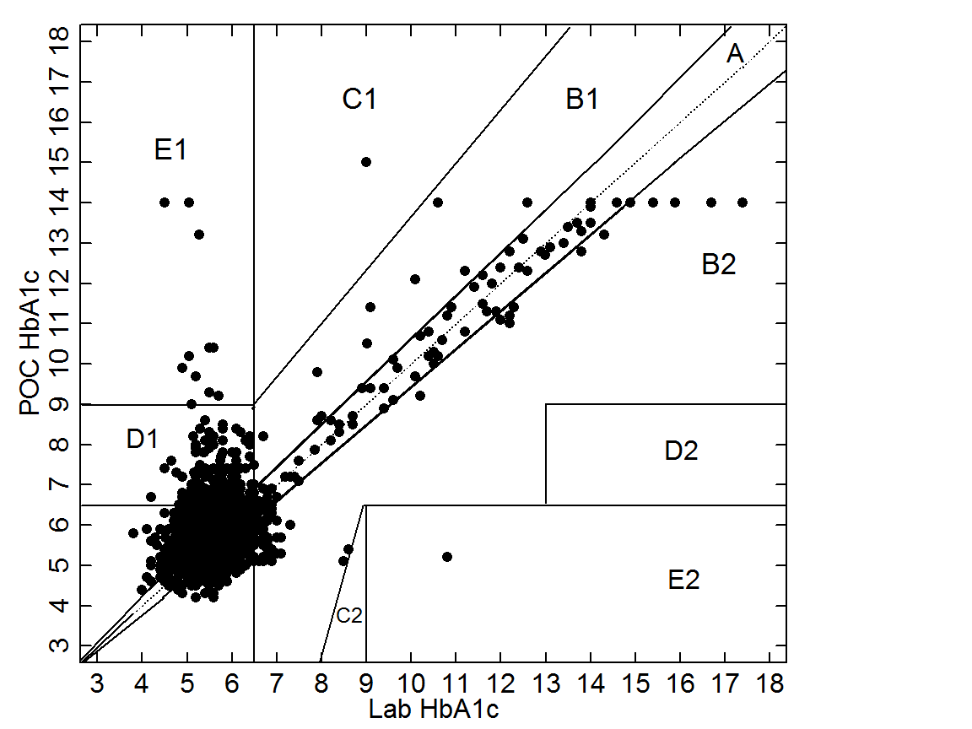
Figure 1. Error grid demonstrating agreement between the laboratory and POC HbA1c measurement

Participant numbers reported here vary slightly from some other TANDEM consortium analyses owing to minor differences in inclusion criteria and/or recruitment period
Underweight: <18.5 kg/m²; normal range: 18.5-24.9 kg/m²; overweight: 25.0-29.9 kg/m²; obese: ≥30.0 kg/m².
Anaemia categories were defined according to WHO. Among non-pregnant women (>15 years) non-anaemia defined as haemoglobin levels >120g/L, mild anaemia defined as 110-119g/L, moderate anaemia was defined as 80-109g/L, and severe anaemia was defined as <80g/L; among men, non-anaemia defined as >130g/L, mild anaemia was defined as 110-129g/L, moderate anaemia defined as 80-109g/L, and severe anaemia defined as <80g/L. Among women, there were five people pregnant and their anaemia level was defined differently as below: non-anaemia >110g/L, mild anaemia is 100-109g/L, moderate anaemia is 70-99g/L, and severe anaemia is <70g/L.
Wald test was used to test overall differences across all categories; P>0.100 for all tested variables except for country (P<0.001) and Lab HbA1c groups (P=0.035).
Underweight: <18.5 kg/m2; normal range: 18.5-24.9 kg/m2; overweight: 25.0-29.9 kg/m2; obese: ≥30.0 kg/m2.
Anaemia categories were defined according to WHO. Among non-pregnant women (>15 years) non-anaemia defined as haemoglobin levels >120g/L, mild anaemia defined as 110-119g/L, moderate anaemia was defined as 80-109g/L, and severe anaemia was defined as <80g/L; among men, non-anaemia defined as >130g/L, mild anaemia was defined as 110-129g/L, moderate anaemia defined as 80-109g/L, and severe anaemia defined as <80g/L. Among women, there were five people pregnant and their anaemia level was defined differently as below: non-anaemia >110g/L, mild anaemia is 100-109g/L, moderate anaemia is 70-99g/L, and severe anaemia is <70g/L.

