Genetic basis of severe childhood-onset cardiomyopathies:
high prevalence of family-specific and de novo pathogenic variants

Short title: Genetics of severe childhood cardiomyopathies

Catalina Vasilescu, MSc,ª Tiina H. Ojala, MD, PhD,^{b} Virginia Brilhante, PhD,ª Simo Ojanen, MSc,ª Helena M. Hinterding, BSc,ª Eino Palin, MD, PhD,ª Tero-Pekka Alastalo, MD, PhD,^{c} Juha Koskenvuo, MD, PhD,^{c} Anita Hiippala, MD, PhD,^{b} Eero Jokinen, MD, PhD,^{b} Timo Jahnukainen, MD, PhD,^{d} Jouko Lohi, MD, PhD,^{e} Jaana Pihkala, MD, PhD,^{b} Tiina A. Tyni, MD, PhD,^{a,f} Christopher J. Carroll, PhD,ª Anu Suomalainen, MD, PhD^{a,g,h*}

Total word count:

ªResearch Programs Unit, Molecular Neurology, Biomedicum-Helsinki, University of Helsinki, 00290 Helsinki, Finland
^{b}Department of Pediatric Cardiology, Helsinki University Hospital and University of Helsinki, 00290 Helsinki, Finland
^{c}Blueprint Genetics, 00290 Helsinki, Finland
^{d}Department of Pediatric Nephrology and Transplantation, Helsinki University Hospital and University of Helsinki, 00290 Helsinki, Finland
^{e}Department of Pathology, Helsinki University Hospital and University of Helsinki, 00290 Helsinki, Finland
^{f}Department of Pediatric Neurology, Helsinki University Hospital and University of Helsinki, 00290 Helsinki, Finland
^{g}Department of Neurology, Helsinki University Hospital and Clinical Neurosciences, University of Helsinki, 00290 Helsinki, Finland
^{h}Neuroscience Center, University of Helsinki, 00790 Helsinki, Finland

Funding
Jane and Aatos Erkko Foundation, Sigrid Jusélius Foundation, Academy of Finland, University of Helsinki, Helsinki Doctoral Programme in Biomedicine, Finnish Cultural Foundation, and Foundation for Pediatric Research Finland.

Disclosures
TPA and JK are co-founders and directors of Blueprint Genetics, which offers genetic diagnostics for cardiomyopathies. The other authors have no disclosures to make.

Address for correspondence
To whom correspondence should be addressed: Professor Anu Suomalainen, Research Programs Unit, Molecular Neurology, Biomedicum-Helsinki, University of Helsinki, r.C523B, Haartmaninkatu 8, 00290 Helsinki, Finland. E-mail: anu.wartiovaara@helsinki.fi, Telephone: +358-9-4717 1965, Fax: +358-9-4717 1964, Twitter: @AWartiovaara

Acknowledgments
The authors thank Anu Harju, Tuula Manninen, and Markus Innilä for technical support.

Abstract
Background
Childhood cardiomyopathies are progressive and often lethal disorders, forming the most common cause of heart failure in children. Despite severe outcomes, their genetic background is still poorly characterized.
Objectives
To characterize the genetics of severe childhood cardiomyopathies in a country-wide cohort.
Methods
We collected a country-wide cohort, KidCMP, of 66 severe childhood cardiomyopathies from the sole center in Finland performing cardiac transplantation. For genetic diagnosis, we employed next-generation sequencing and subsequent validation using genetic, cell biology, and computational approaches.
Results
The KidCMP cohort presents a remarkable early onset and severe disorders: the median age-of-diagnosis was 0.33 years, and seventeen patients underwent cardiac transplantation. We identified the pathogenic variants in 39% of patients: 46% de novo, 34% recessive, and 20% dominantly-inherited. We report NRAP underlying childhood dilated cardiomyopathy, as well as novel phenotypes for known heart disease genes. Some genetic diagnoses have immediate implications for treatment: CALM1 with life-threatening arrhythmias, and TAZ with good cardiac prognosis. The disease genes converge on metabolic causes (PRKAG2, MRPL44, AARS2, HADHB, DNAJC19, PPA2, TAZ, BAG3), MAPK pathways (HRAS, PTPN11, RAF1, TAB2), development (NEK8 and TBX20), calcium signaling (JPH2, CALM1, CACNA1C) and the sarcomeric contraction cycle (TNNC1, TNNI3, ACTC1, MYH7, NRAP).
Conclusions
Childhood cardiomyopathies are typically caused by rare, family-specific mutations, most commonly de novo, indicating that next-generation sequencing of trios is the approach-of-choice in their diagnosis. Genetic diagnoses may suggest intervention strategies and predict prognosis, offering valuable tools for prioritization of patients for transplantation versus conservative treatment.

Condensed abstract
Childhood cardiomyopathies are progressive and often lethal disorders, forming the most common cause of heart failure in children. However, their genetic background is still poorly characterized. To address this knowledge gap, we used next-generation sequencing to characterize the genetics of childhood cardiomyopathies in a country-wide cohort, KidCMP, remarkable by early-onset disorders. KidCMP shows that childhood cardiomyopathies are typically caused by rare, family-specific mutations, most commonly de novo, indicating that next-generation sequencing of trios is the approach-of-choice in their diagnosis. Genetic diagnoses may suggest intervention strategies and predict prognosis, offering valuable tools for prioritization of patients for transplantation versus conservative treatment.

Keywords: next-generation sequencing, de novo mutations, pediatric, heart failure, cardiac transplant, genotype-phenotype correlation

Abbreviations and acronyms
CMP = cardiomyopathy
DCM = dilated cardiomyopathy
HCM = hypertrophic cardiomyopathy
LVNC = left ventricular noncompaction
RCM = restrictive cardiomyopathy
HICM = histiocytoid cardiomyopathy

Main text
Cardiomyopathies (CMPs) are the most common cause of childhood heart failure and may manifest as isolated heart disorders or as components of developmental and metabolic disorders. The current genetic approaches lead to a molecular diagnosis in about one third of early-onset cardiomyopathies, therefore the spectrum of genetic causes in children is still largely unknown (1). The genetic background of these diseases is relatively understudied, partially explained by their rarity and heterogeneity. Next-generation sequencing (NGS), covering broad genomic regions, has become the methodology of choice for CMPs, as shown by recent adult-onset studies (2). We collected a unique country-wide cohort of severe childhood-onset CMP patients (“KidCMP”), naïve from genetic point of view, as most of the patients did not have a molecular diagnosis at the initiation of this study. We present here the clinical and genetic characterization of KidCMP cohort and indicate the importance of early diagnosis in treatment optimization.

Methods
Patients
KidCMP consists of 66 childhood-onset CMP patients who visited between 1993 and 2014 the Pediatric Cardiology Department of the Helsinki University Central Hospital, the single center in Finland performing cardiac transplantations. The children were younger than 16 years at presentation, and the majority of Finnish ancestry. We included in the cohort only the most severe patients who were submitted to our center for inotropic support, invasive hemodynamic examinations, and/or pre-transplantation evaluation. These patients constitute about 40% of the annual occurrence of childhood cardiomyopathies in Finland (1.38/100,000 population younger than 15 years), estimation based on the prevalence of idiopathic cardiomyopathy between 1980-1991 (3); this prevalence is slightly higher occurrence than the prevalence in a large epidemiological study from Australia (1.24/100,000 population younger than 10 years) (4). All the invasive and pre-transplantation evaluations are centralized to Helsinki in Finland. We have performed clinical and echocardiographic evaluation for all individuals presented in pedigrees (children and adults , affected or unaffected ). The patients with syndromic or extracardiac symptoms were examined by a clinical geneticist. The assignment of patients to a diagnostic category followed the statement of the European Society Working Group on myocardial and pericardial diseases (Supplemental methods). All the patients are followed up until 16 years of age in children’s hospital and afterwards in adults’ cardiology department. The samples were taken with informed patient (when >10 years) and/or parental consent (when children were <10 years), according to the Declaration of Helsinki.
Next-generation sequencing (NGS)
Of the 66 patients, six were separately diagnosed for their gene defect, and 60 were analyzed here by NGS methods. We utilized two targeted sequencing panels: 32 patients were screened with the CMP-Custom HaloPlex Panel which includes 117 cardiac genes (Agilent Technologies, Online Table 1); 29 patients were screened with Pan Cardiomyopathy v.1.0 Panel (Blueprint Genetics, Online Table 2) of 101 cardiomyopathy-related genes. Further, we sequenced the whole exome of 20 patients. Ten patients have been screened with more than one method. Typically, we analyzed only the samples of index patients, with the exception of three families, where additional family members have been included. Supplemental methods and Online Figure 1 present the bioinformatic analyses, variant filtering strategy, and the comparison of gene panels.
For interpretation of sequence variants, we followed the guidelines of the American College of Medical Genetics and Genomics (ACMG) (5). In short, the prioritized variants were: 1) known to cause CMP (literature, OMIM, ClinVar, Uniprot), 2) new variants in genes that were relevant for cardiac function, 3) de novo variants in known CMP genes. Further, all the variants considered disease-causing segregated with disease in families, were absent in control databases if dominant, or present only as heterozygotes if recessive, and altered an evolutionary conserved amino acid in the protein, showing at the same time multiple lines of computational evidence supporting pathogenicity. As control databases, we used gnomAD with genetic data from 138,632 individuals, ExAC comprising 60,706 individuals, and the Finnish SISu v4.0 with 10,490 ethnic controls. Genetic diagnoses published earlier from the same cohort are included only to depict the overall genetic landscape of the KidCMP cohort, but not detailed further in tables and pedigrees.
Validation of genetic findings
In this study we focused only on validation of fully penetrant pathogenic variants that co-segregated with disease in families. The variant validation in patients and the family screening employed Sanger sequencing. De novo variant status, determined by being absent in parental samples, was further confirmed by DNA fingerprinting of patient and parents using seven microsatellite markers. Parental samples were unavailable for some patients with potential de novo mutations. We classified four of them as ‘likely de novo’ based on the family history without clinical signs or echocardiographic findings in the first-degree relatives (P16), and previous reports of the variants as occurring de novo (P8, P9), or consistently early severe phenotype in all published patients with the variant (P7). Supplemental methods include protein and RNA analyses of variants. All - primers used in this study are listed in Online Table 3.

Results
KidCMP cohort
The major clinical characteristics of KidCMP cohort are presented in Figure 1A-C and Table 1, which highlight: a) DCM as the most frequent diagnosis in the cohort, b) remarkable early-onset with the median age-of-diagnosis of 0.33 years (mean of 2.05 years) as 65% of patients manifested the disease before one year of age, c) severe diseases, as 17 patients underwent cardiac transplantation and 18 have died of their disorder. The average transplant timing was 1.97 years (median 1 year) and the average death timing occurred 2.24 years (median 0.315 years) after the initial diagnosis.
Forty-three patients were females, 23 males. Typically, patients presented a specific cardiomyopathy, but five showed additional features (three patients HCM/LVNC, one DCM/LVNC, one LVNC/DCM). Nine patients (3 DCM, 3 HCM, 2 LVNC, 1 HICM) manifested heart rhythm disturbances (5 LQTs, 2 ventricular tachycardia, 1 AV nodal reentrant tachycardia, and 1 tachycardia related to Wolff-Parkinson-White syndrome).
Of all, 49 had no familial history, suggesting an autosomal recessive inheritance or de novo occurrence. Seventeen families presented additional members affected by disease: in seven families with multiple affected siblings and healthy parents, with no findings of subclinical disease, we assumed recessive inheritance, while ten families showed dominant inheritance, with one of the parents manifesting the disease.
High heterogeneity of genetic causes with frequent de novo mutations
Overall in the KidCMP cohort, we uncovered the genetic cause in 26 out of the 66 patients (39%). Regarding samples screened with multiple methods, the concordance of positive findings between panels was 7 from 8 (88%), due to a gene not covered in both, and between panels and exomes was 6 from 12 (50%), accounting for genes not covered in panels. Separately diagnosed from the same cohort were: MRPL44 (6), AARS2 (7), DNAJC19 (8), HADHB (9), PRKAG2 (10), and HRAS (11). In the current screening, we identified disease-causing variants in the following disease genes (Figure 1D and pedigrees in Figure 2): PPA2, TAZ, BAG3, NEK8, TBX20, TAB2, PTPN11, RAF1, JPH2, CALM1, CACNA1C, TNNC1, TNNI3, ACTC1, MYH7, and NRAP. Table 2 summarizes the main clinical features and the details of identified genetic variants. Additionally, we detected variants of unknown significance that have been previously linked to pathologies (Table 3).
Each disease-causing variant was family-specific. Amongst all 26 molecular diagnoses in the cohort, 12 (46%) were de novo, nine (34%) recessive, and five (20%) dominantly inherited. Figure 1E depicts the variants with severe outcome (heart transplant or death), among which 10 (63%) were de novo, 5 (31%) recessive, and 1 (6%) dominantly inherited.
Among the 66 patients of KidCMP cohort, 22 (33%) present a systemic disorder, of which 16 (72%) have the age of onset <1 year. A genetic diagnosis was found in 54% of the patients with a systemic disease, and in 32% of isolated cardiomyopathies. When analyzed by age of onset, our cohort shows an increase in success of genetic diagnosis with later onset: <1 year 34% positive DNA diagnosis, 1-5 years 38%, 6-10 years 60%, 11-15 years 60%. Two thirds of the infantile (<1year) DNA diagnoses were explained by recessive metabolic genes or de novo variants affecting calcium signaling and Ras/MAPK pathways.
We mapped the identified variants to protein domains, together with the previously reported disease-causing variants, if such existed (Online Figures 2-4). The conservation and clustering in hotspots and functional domains supported their pathogenicity. Online Table 4 summarizes functional information on the variants, including molecular modeling, protein analyses, and additional data from the literature. We report NRAP as a novel cause of childhood severe DCM, as well as new phenotypes for known disease genes. Here we describe in detail the most novel genetic findings or atypical clinical manifestation, as well as the diagnoses with immediate implications for treatment.
NRAP truncation can cause childhood CMP
P20, the third child of non-consanguineous parents, was diagnosed at the age of 3.5 years with DCM after mild upper respiratory viral infection. Serum antibody titers suggested adenovirus. Cardiac magnetic resonance imaging showed large and edemic left ventricle, with an end-diastolic volume of 245 ml/m² (>3SD) and poor ejection fraction of 15%. No late enhancement was observed, and myocarditis was suspected.
The patient was treated for two weeks with inotropes (milrinone, levosimendane, diuretics). Despite of this treatment she presented cardiac arrest and was placed on left ventricular assist device (LVAD). Cardiac muscle biopsy, taken while the patient was cannulated to the LVAD, was supportive for mild myocarditis, but no virus could be extracted from the sample. Endomyocardial biopsies showed elongation of cardiomyocytes, focal interstitial fibrosis and patchy lymphocytic inflammation. CD3 positive T-lymphocytes were found with maximal density of 70 lymphocytes/mm² fulfilling the Marburg criteria for myocarditis. However, immunohistochemical stainings for adenovirus, as well as cytomegalovirus and parvovirus B19, and in situ hybridization for EBV-encoded RNA (EBER) were negative. Examinations showed otherwise normal findings (routine laboratory analyses, cardiac muscle or skeletal muscle histology for morphology, structural proteins, and metabolic enzyme activity). The patient showed no response to treatment, and died 1.5 months after the initial diagnosis, following a complication of the LVAD, while waiting for cardiac transplant. Autopsy findings were consistent with DCM, but showed no evidence for inflammation. The mild/lack of inflammation findings were considered not to explain the fast progression of the disease, but could have been a contributing factor to accelerate a genetic disease. Exome analysis identified a homozygous nonsense variant in NRAP (Nebulin-related-anchoring protein, NM_001261463, NP_001248392, c.1344T>A, p.(Y448*)). The protein is involved in anchoring terminal actin filaments to the membrane, tension transmission from myofibrils to extracellular matrix, as well as myofibril assembly, and it has been recently linked to adult-onset DCM. Although the predicted protein truncation at amino acid 488 (total length of 1731 amino acids, Figure 3A) likely leads to a complete loss of function, we showed that the NRAP mRNA harboring the premature stop codon is not degraded in patient’s heart biopsy (Figure 3B-D). Based on its involvement in actin anchoring to membrane and myofibrillogenesis, together with previous knowledge of NRAP in adult DCM, we judged the defect to be a new cause of childhood severe DCM.
Atypical clinical manifestations
PPA2 in rapidly progressing DCM. P1 and his brother, born to healthy non-consanguineous parents, developed a rapidly progressive DCM and cardiac failure, with only few days from disease onset to death, at the age of 8 and 5 months, respectively. Both had mild viral infection symptoms (diarrhea, vomiting) prior to the rapid deterioration of their condition. The careful echocardiographic follow-up of the second brother showed normal findings until the sudden disease manifestation, when both DCM and poor function were observed. Autopsy showed dilation of left ventricles and evidence of focal fibrosis, inflammatory infiltrates with acute myocyte loss. Exome analysis indicated rare recessive variants in PPA2 (NM_176869, NP_789845, c.514G>A, p.(E172K), with a frequency of 0.0004 in Finns and c.556G>A, p.(V186M), absent in public databases). PPA2 encodes inorganic pyrophosphatase 2, a mitochondrial enzyme that hydrolyses inorganic pyrophosphate to orthophosphate, and contributes to ATP synthesis. Both amino acid sites showed very high conservation, down to baker’s yeast (Saccharomyces cerevisiae). Molecular modeling of the identified variants suggested compromised stability of the protein (Figure 4A-D), which was further confirmed by Western blotting using protein extracts from patient fibroblasts (Figure 4E). The loss of inorganic pyrophosphatase 2 was accompanied by a reduction of mitochondrial respiratory chain Complex IV, more prominent in blue native-PAGE (Figure 4G-H), suggesting an unknown role of pyrophosphate in Complex IV assembly or stability. In conclusion, PPA2 defects, previously involved in sudden death, can cause DCM, underlying the acute manifestation and sudden infantile death.
TBX20 in familial LVNC. The autosomal dominant family history of CMP motivated an annual echocardiographic follow-up of patient P4 since infancy. She had recurrent pneumonias during childhood and Ig-A deficiency. At the age of 9 years, LVNC with restrictive physiology was diagnosed. She developed increased pulmonary vascular resistance and pressure, and received a heart transplant at 15 years of age. She died suddenly at the age of 18 years, during a mild upper respiratory tract infection. The patient’s mother was diagnosed to have heart rhythm disturbances, LVNC and DCM at the age of 18 years, and she had an ICD implanted. The maternal grandmother died suddenly at home at 45 years of age. We identified a novel autosomal dominant variant in TBX20 (NM_001077653, NP_001071121, c.670A>G, p.(M224V)), encoding a transcription factor essential for heart development. Molecular modeling indicated a structural role for the affected amino acid M224, stabilizing the T-box domain of TBX20 in the major groove of DNA (Figure 5). The T-box domain is responsible for binding DNA in a sequence-specific manner. The affected amino acid is highly conserved in evolution down to the marine invertebrate Ciona intestinalis, and the variant also segregated in family, supporting pathogenicity. Our data show that TBX20 variants can lead to dominantly-inherited LVNC, without other structural heart defects.
JPH2 in childhood CMP. P10 was diagnosed with DCM at the age of 3 years and heart transplantation was performed one year later. We identified a homozygous nonsense variant c.1282C>T, p.(Q428*) in JPH2, a gene previously not associated with recessive disease.
Junctophilin-2 is a component of junctional complexes between sarcolemma and sarcoplasmic reticulum in cardiomyocytes, playing important roles in calcium homeostasis and dyad architecture. The homozygous p.(Q428*) of P10 introduces a stop codon early in the coding sequence of the protein (Online Figure 3A), which can determine either the mRNA degradation or render the protein nonfunctional as it loses its transmembrane anchor. Our data indicate that Junctophilin-2 missense variants, mainly associated with adult-onset dominant disorders, can also cause childhood-onset recessive DCM.
Diagnoses with implications for treatment
CALM1 disorder with life-threatening arrhythmias. P11 received the diagnoses of long QT syndrome and 2:1 atrioventricular (AV) block in newborn period. At four months of age she showed neurodevelopmental delay with infantile spasms. The AV-block resolved with beta-blocker medication, as QT shortened. The patient was treated with dual chamber pacemaker for severe bradycardia, and left cardiac denervation for torsades-de-pointes arrhythmia was performed at the age of 3 years. Cardiac MRI confirmed LVNC and severe systo-diastolic dysfunction. The patient died of cardiac ischemia and insufficiency, after anesthesia for cardiac catheterization, gastrostomy, and central venous line insertion. We identified a novel de novo mutation in CALM1 (Calmodulin, NM_006888, NP_008819, c.424T>A, p.(F142I)), which plays a crucial role in calcium signaling. Pathogenic variants in CALM1 affect the EF-hand domains involved in calcium binding. The identified variant p.(F142I) resides near EF-hand 4, at the same amino acid position where another pathogenic variant has been reported (Online Figure 3A). Our patient indicates that CALM1 may cause syndromic progressive LVNC of neonatal onset, and the highly arrhythmogenic nature of the disease should be considered upon interventions for CMP.
TAZ disorder with a recuperative course. Patient P2 presented with heart failure at the age of 3 months, was successfully resuscitated and diagnosed with DCM. He responded well to heart failure medication. He had microcephaly (-2.8 SD), the speech development was mildly delayed, but the motor development was normal. The patient presented increased 4-hydroxyphenylpyruvate (176 mmol/mol creatine, normal value < 5) and 4-hydroxyphenyllactate (110 mmol/mol creatine, normal < 20). His cardiac findings normalized and all the heart failure treatments were ceased by 11 years of age. His brother manifested similarly at the age of 3 months with heart failure due to DCM. Later, cardiac findings have normalized and all the heart failure treatments were ceased by 6 years of age. At the age of 15 years, he was examined for an unspecific abdominal pain, with the detection of leukopenia and a mildly increased size of liver and spleen. 3-Methylglutaconic aciduria has not been observed. We identified a known pathogenic variant in TAZ (tafazzin, NM_000116, NP_000107, c.718G>A, p.(G240R)) as the underlying cause of disease in both brothers. Their mother is a healthy carrier, typical for an X-linked disorder. Tafazzin is an acyltransferase responsible for the maturation of cardiolipin, the major phospholipid in the inner mitochondrial membrane. The disease-causing variants reported in TAZ are located within or adjacent to the phospholipid acyltransferase domain, except the variant found in our study (Online Figure 3B), providing a potential explanation for the recuperative disease course. Our patients indicate that TAZ variants can manifest as early-onset DCM with good cardiac prognosis.
Supplemental material contains additional clinical reports and illustrations of the involved proteins.

Discussion
Genetic landscape of severe childhood CMPs
We report here a genetic landscape of severe childhood CMPs, in a country-wide cohort of patients submitted for inotropic support, invasive hemodynamic examinations, and/or pre-transplantation evaluation, representing 40% of total CMPs occurrence in Finland as estimated in a 12-year epidemiological study (3). We identified the causative variants in 39% of the patients, where the nucleotide/protein changes 1) were remarkably conserved in species, 2) affected important functional domains in the proteins, 3) segregated in families or were de novo, 4) were absent (when dominant) or rare (when recessive) in population control databases.
Our cohort shows a trend towards overrepresentation of female patients, also found in a previous Finnish epidemiological study, in patients diagnosed before one year of age. However, in over one year olds our cohort still shows a trend female preponderance, whereas previous epidemiological studies show overrepresentation of males (3,4,12). Larger cohorts are needed to conclude about a gender bias in infantile cardiomyopathies.
In our cohort, the causative variants were private to families and ancestral mutations were not found, even in a genetic isolate such as Finland. We show that de novo variants are a common cause of early-onset CMPs, accounting for almost half of genetic diagnoses, followed by recessive (including X-linked) with one third, and lastly by dominantly-inherited variants. Our data show that, similar to adult CMPs (13), the proteins involved in the sarcomeric contraction cycle are major determinants of childhood CMPs, but also MAPK pathways, calcium signaling, and metabolic causes are common. Moreover, we identified NRAP truncation as a new cause for childhood DCM, while recently it was described in adult-onset DCM with incomplete penetrance (14).
New phenotypes for known heart disease genes
PPA2 defects, reported in infants and young adults who died suddenly between 11 days and 20 years of age (15,16), caused rapidly-progressing DCM in our cohort. We found that NEK8 should be considered in infantile CMP with liver involvement even without renal dysfunction, which was recurrently reported in previous patients (17). Moreover, TBX20 should be also examined in patients with dominantly-inherited LVNC, without other structural heart defects, which constituted the main presentation in other patients (18-20). TAB2 haploinsufficiency, previously involved in congenital heart disease (21), caused infantile DCM in our cohort. JPH2 defect, known to underlie dominant HCM (22), DCM (23), and paroxysmal atrial fibrillation (24), manifested in our cohort with childhood-onset recessive DCM. The pathogenicity of our patient’s recessive loss of function variant is supported by previous mouse models of JPH2 deficiency (25,26). CALM1 variants, often de novo, cause catecholaminergic polymorphic ventricular tachycardia and recurrent cardiac arrests (27), sometimes with neurological involvement (28). In our cohort CALM1 de novo variant led to syndromic LVNC of neonatal onset, with a highly arrhythmogenic disease, requiring special consideration upon intervention.
Variable manifestation of specific variants
KidCMP cohort supports the idea that specific genetic variants can present different manifestations, although the severe course is a common theme: TNNC1 p.(A31S), previously associated with HCM (29), manifested as RCM. CACNA1C variant p.(G406R) reported in Timothy syndrome type 2 (30), may also manifest as non-systemic disorder as apparent in our patient, the second identified with this mutation.
De novo hot spots
The variants identified in BAG3, PTPN11, and RAF1 occurred at amino acid positions that are known hot spots for de novo variation (31-34), and overall, de novo variants seem to play a major role in childhood CMP genetics.
Progressive versus recuperative courses
In our cohort, some specific gene variants led to primary progressive and others to stabilizing or even recuperating disease course. This underscores the importance of genetic diagnosis for directing treatment decisions. To illustrate this point, the cardiac findings in mitochondrial cardiomyopathies (TAZ, MRPL44, and DNAJC19) stabilized spontaneously in the minority of patients, who survived through the early years. Most of the reported patients with the TAZ variant p.(G240R) died in infancy (35), but three (two brothers in our study and one patient reported elsewhere (35)) manifested infantile DCM, which stabilized later. In our TAZ patients supportive heart medication became unnecessary by 6-11 years of age. Previous reports include resolving cardiomyopathy in patients with defects in mitochondrial translation factor TSFM(36), and in the case of mitochondrial ATP synthase deficiency as a consequence of TMEM70 mutations (37), both disorders followed later by extracardiac manifestations. In KidCMP, also a specific sarcomeric protein defect, MYH7 p.(R925G), was associated with cardiac stabilization at 3-4 years of age. The potential of partial recovery of CMP, especially in mitochondrial CMPs, emphasizes an intensive, conservative treatment strategy to support the heart function of these patients through their infantile years.
Study limitations
In five out of 20 families with new DNA diagnoses in the cohort we were unable to obtain samples from the parents, limiting our segregation study of the identified variants. However, these first-degree relatives from whom DNA samples were not available, cardiac examination, including echocardiography, was performed, with no subclinical cardiac findings in subjects marked healthy in pedigrees. We have not tested genetic interactions in this study, although early-onset CMPs have been sometimes suggested to be explained by double heterozygosity in sarcomeric/cytoskeletal proteins, or by an oligogenic model of disease where multiple variants combine their effects to cause disease. Whole- genome sequencing coupled with novel variant discovery strategies should be employed to uncover genetic underpinnings in the rest of the cohort.
Conclusions
Our study emphasizes a personalized medicine approach: NGS-based analysis and the exact DNA diagnosis in severe infantile and childhood CMPs enable genetic counseling of the family. Furthermore, understanding of the natural history of disease progression for specific genotypes importantly contributes to treatment decisions, such as prioritization of cardiac transplantation in primary progressive diseases or emphasis on intensive conservative treatment (Central Illustration). Further, the identification of genetic components in childhood CMPs provides knowledge on the molecular pathogenesis of the disease, crucial for future design of therapeutic strategies.

Perspective
Competency in medical knowledge
Our NGS approach in childhood CMPs revealed a remarkable genetic heterogeneity, with family-specific, often de novo, variants, suggesting that NGS trios should be instituted as first line diagnostic in children considered for heart transplant.
Translational outlook
Based on our data, specific gene variants lead to primary progressive disease course and others may stabilize or even recuperate. This evidence indicates that genetic diagnosis has important implications for treatment decisions, including prioritization for cardiac transplantation or conservative treatment.

References
1. Lee TM, Hsu DT, Kantor P et al. Pediatric Cardiomyopathies. Circ Res 2017;121:855-873.
2. Akinrinade O, Ollila L, Vattulainen S et al. Genetics and genotype-phenotype correlations in Finnish patients with dilated cardiomyopathy. Eur Heart J 2015;36:2327-37.
3. Arola A, Jokinen E, Ruuskanen O et al. Epidemiology of idiopathic cardiomyopathies in children and adolescents. A nationwide study in Finland. Am J Epidemiol 1997;146:385-93.
4. Nugent AW, Daubeney PEF, Chondros P et al. The epidemiology of childhood cardiomyopathy in Australia. N Engl J Med 2003;348:1639-46.
5. Richards S, Aziz N, Bale S et al. Standards and guidelines for the interpretation of sequence variants: a joint consensus recommendation of the American College of Medical Genetics and Genomics and the Association for Molecular Pathology. Genetics in medicine : official journal of the American College of Medical Genetics 2015;17:405-24.
6. Carroll CJ, Isohanni P, Poyhonen R et al. Whole-exome sequencing identifies a mutation in the mitochondrial ribosome protein MRPL44 to underlie mitochondrial infantile cardiomyopathy. J Med Genet 2013;50:151-9.
7. Gotz A, Tyynismaa H, Euro L et al. Exome sequencing identifies mitochondrial alanyl-tRNA synthetase mutations in infantile mitochondrial cardiomyopathy. Am J Hum Genet 2011;88:635-42.
8. Ojala T, Polinati P, Manninen T et al. New mutation of mitochondrial DNAJC19 causing dilated and noncompaction cardiomyopathy, anemia, ataxia, and male genital anomalies. Pediatr Res 2012;72:432-7.
9. Ojala T, Nupponen I, Saloranta C et al. Fetal left ventricular noncompaction cardiomyopathy and fatal outcome due to complete deficiency of mitochondrial trifunctional protein. Eur J Pediatr 2015.
10. Poyhonen P, Hiippala A, Ollila L et al. Cardiovascular magnetic resonance findings in patients with PRKAG2 gene mutations. J Cardiovasc Magn Reson 2015;17:89.
11. Hiippala A, Vasilescu C, Tallila J et al. The rare Costello variant HRAS c.173C>T (p.T58I) with severe neonatal hypertrophic cardiomyopathy. Am J Med Genet A 2016;170:1433-8.
12. Lipshultz SE, Sleeper LA, Towbin JA et al. The incidence of pediatric cardiomyopathy in two regions of the United States. N Engl J Med 2003;348:1647-55.
13. Morita H, Rehm HL, Menesses A et al. Shared genetic causes of cardiac hypertrophy in children and adults. N Engl J Med 2008;358:1899-908.
14. Truszkowska GT, Bilinska ZT, Muchowicz A et al. Homozygous truncating mutation in NRAP gene identified by whole exome sequencing in a patient with dilated cardiomyopathy. Scientific reports 2017;7:3362.
15. Guimier A, Gordon CT, Godard F et al. Biallelic PPA2 Mutations Cause Sudden Unexpected Cardiac Arrest in Infancy. Am J Hum Genet 2016;99:666-73.
16. Kennedy H, Haack TB, Hartill V et al. Sudden Cardiac Death Due to Deficiency of the Mitochondrial Inorganic Pyrophosphatase PPA2. Am J Hum Genet 2016;99:674-82.
17. Rajagopalan R, Grochowski CM, Gilbert MA et al. Compound heterozygous mutations in NEK8 in siblings with end-stage renal disease with hepatic and cardiac anomalies. Am J Med Genet A 2016;170:750-3.
18. Kirk EP, Sunde M, Costa MW et al. Mutations in cardiac T-box factor gene TBX20 are associated with diverse cardiac pathologies, including defects of septation and valvulogenesis and cardiomyopathy. Am J Hum Genet 2007;81:280-91.
19. Posch MG, Gramlich M, Sunde M et al. A gain-of-function TBX20 mutation causes congenital atrial septal defects, patent foramen ovale and cardiac valve defects. J Med Genet 2010;47:230-5.
20. Zhao CM, Bing S, Song HM et al. TBX20 loss-of-function mutation associated with familial dilated cardiomyopathy. Clin Chem Lab Med 2015.
21. Thienpont B, Zhang L, Postma AV et al. Haploinsufficiency of TAB2 causes congenital heart defects in humans. American journal of human genetics 2010;86:839-49.
22. Landstrom AP, Weisleder N, Batalden KB et al. Mutations in JPH2-encoded junctophilin-2 associated with hypertrophic cardiomyopathy in humans. J Mol Cell Cardiol 2007;42:1026-35.
23. Sabater-Molina M, Navarro M, Garcia-Molina Saez E et al. Mutation in JPH2 cause dilated cardiomyopathy. Clin Genet 2016.
24. Beavers DL, Wang W, Ather S et al. Mutation E169K in Junctophilin-2 Causes Atrial Fibrillation Due to Impaired RyR2 Stabilization. J Am Coll Cardiol 2013;62:2010-2019.
25. Chen B, Guo A, Zhang C et al. Critical roles of junctophilin-2 in T-tubule and excitation-contraction coupling maturation during postnatal development. Cardiovasc Res 2013;100:54-62.
26. Reynolds JO, Chiang DY, Wang W et al. Junctophilin-2 is necessary for T-tubule maturation during mouse heart development. Cardiovasc Res 2013;100:44-53.
27. Nyegaard M, Overgaard MT, Sondergaard MT et al. Mutations in calmodulin cause ventricular tachycardia and sudden cardiac death. American journal of human genetics 2012;91:703-12.
28. Crotti L, Johnson CN, Graf E et al. Calmodulin mutations associated with recurrent cardiac arrest in infants. Circulation 2013;127:1009-17.
29. Parvatiyar MS, Landstrom AP, Figueiredo-Freitas C, Potter JD, Ackerman MJ, Pinto JR. A mutation in TNNC1-encoded cardiac troponin C, TNNC1-A31S, predisposes to hypertrophic cardiomyopathy and ventricular fibrillation. J Biol Chem 2012;287:31845-55.
30. Splawski I, Timothy KW, Decher N et al. Severe arrhythmia disorder caused by cardiac L-type calcium channel mutations. Proc Natl Acad Sci U S A 2005;102:8089-96; discussion 8086-8.
31. Pandit B, Sarkozy A, Pennacchio LA et al. Gain-of-function RAF1 mutations cause Noonan and LEOPARD syndromes with hypertrophic cardiomyopathy. Nat Genet 2007;39:1007-12.
32. Razzaque MA, Nishizawa T, Komoike Y et al. Germline gain-of-function mutations in RAF1 cause Noonan syndrome. Nat Genet 2007;39:1013-7.
33. Selcen D, Muntoni F, Burton BK et al. Mutation in BAG3 causes severe dominant childhood muscular dystrophy. Ann Neurol 2009;65:83-9.
34. Takahashi K, Kogaki S, Kurotobi S et al. A novel mutation in the PTPN11 gene in a patient with Noonan syndrome and rapidly progressive hypertrophic cardiomyopathy. Eur J Pediatr 2005;164:497-500.
35. D'Adamo P, Fassone L, Gedeon A et al. The X-linked gene G4.5 is responsible for different infantile dilated cardiomyopathies. American Journal of Human Genetics 1997;61:862-867.
36. Ahola S, Isohanni P, Euro L et al. Mitochondrial EFTs defects in juvenile-onset Leigh disease, ataxia, neuropathy, and optic atrophy. Neurology 2014;83:743-51.
37. Honzik T, Tesarova M, Mayr JA et al. Mitochondrial encephalocardio-myopathy with early neonatal onset due to TMEM70 mutation. Archives of Disease in Childhood 2010;95:296-301.
38. Ratola A, Silva HM, Guedes A et al. A Novel Noonan Syndrome RAF1 Mutation: Lethal Course in a Preterm Infant. Pediatr Rep 2015;7:5955.
39. Thompson D, Patrick-Esteve J, Surcouf JW et al. RAF1 variants causing biventricular hypertrophic cardiomyopathy in two preterm infants: further phenotypic delineation and review of literature. Clin Dysmorphol 2017;26:195-199.
40. Hayashi T, Arimura T, Itoh-Satoh M et al. Tcap gene mutations in hypertrophic cardiomyopathy and dilated cardiomyopathy. J Am Coll Cardiol 2004;44:2192-201.
41. Nishio Y, Makiyama T, Itoh H et al. D85N, a KCNE1 polymorphism, is a disease-causing gene variant in long QT syndrome. J Am Coll Cardiol 2009;54:812-9.

Figure Legends
Central Illustration. Genetic findings in a country-wide cohort of childhood cardiomyopathies with implications for healthcare practices. Next-generation sequencing applied to KidCMP cohort revealed a novel cause for childhood CMP and a high genetic heterogeneity, with frequent de novo mutations. These findings have implications for diagnostic practices, genetic counseling, treatment strategies, and for tracing the molecular networks involved in disease.
Figure 1. Characteristics of Finnish KidCMP cohort. (A) Patients by CMP types. (B) Age at diagnosis color-coded by CMP type. (C) The number of patients who have received a heart transplant, have died, have their cardiac findings currently stabilized with treatment, or present a progressive disorder. (Transplanted patients who died after the intervention are included only in transplant category.) (D) Genetic heterogeneity in the KidCMP cohort. Right: genetic findings in current screening. Left: published earlier from the cohort. Genes marked with dark blue: novel phenotypes. Genes marked with light blue: novel disease genes for CMP or for childhood-onset CMP. (E) Genetic changes with severe outcome in KidCMP cohort and the ages at death or at heart transplant. Variability in clinical manifestations among different patients: *Mother with the same variant did not receive a heart transplant, but had an implantable cardioverter defibrillator (ICD). Underline: nervous system involvement (various degrees). Dashed underline: may lead to nervous system involvement but not apparent in our patient due to early death.
Figure 2. Pedigrees of the families with identified disease-causing variants in this study. The pedigrees are grouped to highlight the molecular pathways affected by disease genes. All individuals presented in pedigrees (children and adults, affected or unaffected) were phenotyped by clinical and echocardiographic evaluation.
Figure 3. NRAP is newly associated with childhood-onset DCM. Red: novel variants found in this study. (A) Representation of NRAP protein with its multiple repeat domains and patients’ variants. (B) Heart biopsies from patient P20 and three controls were used for RNA extraction, cDNA synthesis, and PCR amplification with NRAP specific primers. (C) Quantification of NRAP mRNA normalized by ACTB (Beta-Actin). The error bars show the normalized range of three repeats. (D) Sequencing of NRAP mRNA confirms the presence of the nonsense variant in patient’s transcript.
Figure 4. Functional relevance of PPA2 variants. (A) Schematic representation of PPA2. Variants in this study: red-novel, blue-known. Variants in previous patients: black. (B) Homology model of human PPA2 shows the position and interactions established by wild type V186 and E172. (C) Molecular modeling of p.(V186M) predicts changes in interactions inside the hydrophobic core of the protein. (D) Dramatic change of interactions induced by p.(E172K): loss of stabilizing interactions between two beta sheets and new interactions established with amino acids of the hydrophobic core. (E) SDS-PAGE followed by Western blot show loss of PPA2 in the fibroblasts of patient P1 and his brother. TOM20-control for mitochondrial mass. Mitochondrial Complex IV subunits, MTCO1 and MTCO2, present a subtle decrease in patients’ fibroblasts. (F) Quantification of MTCO1 and MTCO2 levels against nuclear DNA encoded Complex II (SDHA) from the blot shown at (E). (G) Blue native-PAGE followed by Western blot show a dramatically decreased MTCO2 in assembled Complex IV. (H) Quantification of mitochondrial respiratory chain (CI, IV, V) and import (TOM) complexes from the blot shown in (G) against CII.
Figure 5. Functional relevance of the TBX20 variant. (A). Schematic representation of TBX20 with mapped pathogenic variants. The variant discovered in this study - red (novel). (B) Homology model of the T-box domain of human TBX20: the position and interactions established by wild type M244 suggest a structural role for this amino acid, stabilizing the T-box domain in the major groove of DNA. (C) By modeling the patient variant p.(M224V), we observe a loss of stabilizing interactions of the wild type amino acid with V264 and W169.
Table 1. Clinical characterization of KidCMP cohort.
Patients in different age groups | Gender |  | Heart transplant | Death | Cardiac findings normalized | Progressive | Molecular findings
 | F | M |  |  |  |  | Syndromic | Non-syndromic
<1 years  43 | 25 | 18 | 9 | 12 | 13 | 9 | 10/16 | 5/27
1-5 years  13 | 11 | 2 | 4 | 4 | 1 | 4 | 1/5 | 4/8
6-10 years  5 | 4 | 1 | 3 | 0 | 0 | 2 | 0/0 | 3/5
11-15 years  5 | 3 | 2 | 1 | 2 | 0 | 2 | 1/1 | 2/4
Abbreviations: F – female, M – male.

Table 2. Clinical and genetic characteristics of patients with molecular findings in this study.
Patient | Gender | CMP  type | Other symptoms | Age of onset | Age at heart transplant | Age at death | Present  age | Cardiac findings normalized | Gene | Chromosomal position (GRCh37/hg19) | Variant | Inheritance | CADD  C-score  v1.3 | SIFT  Prediction  and score | PolyPhen  Prediction and score | Method | Previous reports of the variant | gnomAD | SISu | ACMG  variant classification
P1 | M | DCM | - | 8 months | - | 8 months | - | - | PPA2 | chr4:g.106359121C/T | c.514G>A  p.(E172K) | AR | 31 | Deleterious  0.01 | Benign  0.427 | WES | Guimier et al (15)  Kennedy et al (16) | 0.00051 | 0.00048 | Pathogenic  PS1,3,+
 |  |  |  |  |  |  |  |  |  | chr4:g.106345452C/T | c.556G>A  p.(V186M) |  | 29.7 | Deleterious  0.02 | Probably damaging  1 | WES | novel variant | - | - | Pathogenic  PS3  PM2,3,+
P2 | M | DCM | - | 3 months | - | - | 22 years | Yes | TAZ | chrX:g.153649015G/A | c.718G>A  p.(G240R) | X-linked  recessive | 31 | Deleterious  0 | Probably damaging  0.935 | Panel | D’Adamo et al (35) | - | - | Pathogenic  PS1,4  PM2,+
P3 | F | RCM | Muscle atrophy  Neuropathy | 13 years | - | 18 years | - | - | BAG3 | chr10:g.121431885C/T | c.626C>T  p.(P209L) | de novo | 34 | Deleterious  0 | Probably damaging  0.999 | Panel | Selcen et al (33)  and others | - | - | Pathogenic  PS1,2,4,+
P4 | F | LVNC | IgA deficiency | 9 years | 15 years | 18 years | - | - | TBX20 | chr7:g.35280634T/C | c.670A>G  p.(M224V) | AD | 25.2 | Deleterious  0 | Probably damaging  0.998 | WES | novel variant | - | - | Likely pathogenic  PM~1,2  PP1,2,3,~4
P5 | F | HCM | Liver cirrhosis and liver transplant  Situs inversus | 3 years | - | - | 10 years | - | NEK8 | chr17:g.27064349T/C | c.644T>C  p.(I215T) | AR | 27.7 | Deleterious  0 | Probably damaging  1 | WES | novel variant | 0.000004 | - | Likely pathogenic  PM~1,2,3,+
 |  |  |  |  |  |  |  |  |  | chr17:g.27065002G/T | c.1055G>T  p.(R352L) |  | 34 | Deleterious  0.03 | Possibly damaging  0.578 | WES | novel variant | 0.00027 | 0.000097 | Likely pathogenic  PM~1,2,3,+
P6 | F | DCM | - | 7 months | 9 months | 2.5 years | - | - | TAB2 | chr6:g.149700219T/- | c.1168delT  p.(S390Qfs*37) | de novo | 33 | - | - | WES | novel variant | - | - | Pathogenic  PVS1  PS2,+
P7 | M | HCM | - | 3 months | - | 3 months | - | - | PTPN11 | chr12:g.112926908C/G | c.1528C>G  p.(Q510E) | likely de novo* | 27.8 | Deleterious  0 | Possibly damaging  0.614 | Panel | Takahashi et al (34)  and others | - | - | Pathogenic  PS1,2,+
P8 | M | HCM | Noonan presentation | 1 day | - | 3 months | - | - | RAF1 | chr3:g.12645699G/A | c.770C>T  p.(S257L) | likely de novo* | 24.8 | Deleterious  0.02 | Benign  0.226 | Panel | Pandit et al (31)  Razzaque et al (32) | - | - | Pathogenic  PS1  PM1,2,6,+
P9 | M | HCM | Noonan presentation | 1 day | 2 years | - | 8 years | - | RAF1 | chr3:g.12645687G/C | c.782C>G  p.(P261R) | likely de novo* | 25.2 | Deleterious  0 | Probably damaging  0.996 | Panel | Ratola et al (38)  Thompson et al (39) | - | - | Likely pathogenic  PM1,2,5,6,+
P10 | F | DCM | - | 3 years | 4 years | - | 22.5 years | - | JPH2 | chr20:g.42747151G/A | hom c.1282C>T  p.(Q428*) | AR | 41 | - | - | Panel | novel variant | 0.000047 | 0.00045 | Pathogenic  PVS1  PM2,3,4,+
P11 | F | LVNC | Long QT  Infantile spasms  Developmental delay | 3 days | - | 4 years | - | - | CALM1 | chr14:g.90871035T/A | c.424T>A  p.(F142I) | de novo | 31 | Deleterious  0 | Probably damaging  0.932 | WES | novel variant | - | - | Pathogenic  PS2  PM1,2,5
P12 | F | LVNC | Long QT | fetus | - | 3 months | - | - | CACNA1C | chr12:g.2614110G/A | c.1216G>A  p.(G406R) | de novo | 32 | Deleterious  0.02 | Probably damaging  0.952 | Panel | Splawski et al (30) | - | - | Pathogenic  PS1,2,+
P13 | F | RCM | Congenital hip dysplasia | 6.5 years | 7 years | 9 years | - | - | TNNC1 | chr3:g.52486233C/A | c.91G>T  p.(A31S) | de novo | 27.7 | Tolerated  0.06 | Probably damaging 0.985 | WES | Parvatiyar et al (29) | - | - | Pathogenic  PS1,2,+
P14 | M | HCM | - | 13.5 years | - | - | 21 years | - | TNNI3 | chr19:g.55665421C/T | c.526G>A  p.(V176M) | AD | 32 | Deleterious  0 | Probably damaging  0.998 | Panel | novel variant | - | - | Likely pathogenic  PM~1,2  PP1,2,3,4
P15 | F | DCM | Mild motor delay | 3 years | - | - | 20.5 years | - | ACTC1 | chr15:g.35084701T/C | c.524A>G  p.(H175R) | AD | 25.8 | Deleterious  0.02 | Probably damaging  0.999 | Panel | novel variant | - | - | Likely pathogenic  PM~1,2  PP1,2,3,4
P16 | M | DCM | - | 13 years | 14 years | - | 29.5 years | - | ACTC1 | chr15:g.35084441A/G | c.658T>C  p.(Y220H) | likely de novo* | 27.2 | Deleterious  0.03 | Probably damaging  0.946 | Panel | novel variant | - | - | Likely pathogenic  PM2,6  PP2,3,4
P17 | F | HCM | - | 5 years | - | - | 13 years | - | MYH7 | chr14:g.23894131A/T | c.2526T>A  p.(S842R) | de novo | 22 | Deleterious  0.04 | Probably damaging  0.971 | Panel | novel variant | - | - | Pathogenic  PS2  PM1,2  PP2,3,4
P18 | F | DCM | - | 10 days | - | - | 7.5 years | Yes | MYH7 | chr14:g.23893265T/C | c.2773A>G  p.(R925G) | AD | 26.2 | Deleterious  0 | Probably damaging  1 | WES | novel variant | - | - | Likely pathogenic  PM1,2  PP1,2,3,4
P19 | M | DCM | - | 4 months | 13 months | - | 14 years | - | MYH7 | chr14:g.23883236T/C | c.5635A>G  p.(K1879E) | de novo | 27.9 | Deleterious  0 | Probably damaging  0.992 | WES | novel variant | - | - | Pathogenic  PS2  PM~1,2  PP2,3,4
P20 | F | DCM | - | 3.5 years | - | 3.8 years | - | - | NRAP | chr10:g.115400070A/T | hom c.1344T>A  p.(Y448*) | AR | 35 | - | - | WES | novel variant | not covered | 0.001 | Pathogenic  PVS1  PM2,3,+
Abbreviations: DCM - dilated cardiomyopathy, HCM - hypertrophic cardiomyopathy, RCM - restrictive cardiomyopathy, hom - homozygous, AD - autosomal dominant, AR - autosomal recessive, WES - whole exome sequencing, CADD - combined annotation-dependent depletion scores, SIFT - Sorting Intolerant From Tolerant tool, ACMG - American College of Medical Genetics and Genomics.
Pathogenicity criteria: PVS - pathogenic very strong, PS - pathogenic strong, PM - pathogenic moderate, PP - pathogenic supporting.
*likely de novo: parental samples unavailable for testing but strong support for pathogenicity and family history negative for the disorder.

Table 3. Variants of unknown significance.
Patient | Gender | CMP  type | Other symptoms | Age of onset | Age at heart transplant | Age at death | Present  age | Cardiac findings normalized | Gene | Chromosomal position (GRCh37/hg19) | Variant | CADD  C-score  v1.3 | SIFT  Prediction  and score | PolyPhen  Prediction  and score | Segregation | Variant previously associated  with disease
P21 | F | LVNC | - | 2 months | 3.5 years | - | 8.5 years | - | TCAP | chr17:g.37822316G/A | c.458G>A  p.(R153H) | 13.42 | Tolerated  0.13 | Benign  0.004 | Uncertain. One family member has signs of heart disease but does not carry the variant. | Hayashi et al (40)  Variant reported to cause HCM
P22 | F | HCM | LQTs  Mild mental retardation | Prenatal | - | - | 10 years | - | KCNE1 | chr21:g.35821680C/T | homozygous  c.253G>A  p.D85N | 21.8 | Deleterious  0.04 | Benign  0.441 | Yes | Nishio et al (41)  Variant reported to cause LQTs
P23 | F | DCM | - | 2 years | - | 2 years | - | - | MT-CO1 | M:6489C/A | homoplasmic  c.586C>A  p.(L196I) | 23.7 | Deleterious low confidence  0.02 | Probably damaging  0.998 | - | mitomap.org
P24 | M | HCM | - | 1 day | - | 1 day | - | - | MT-CYB  (in 2 unrelated patients) | M:15257G/A | homoplasmic  c.511G>A  p.D171N | 23.5 | Deleterious low confidence  0.01 | Possibly damaging  0.553 | - | Conflicting reports.  mitomap.org
P25 | M | DCM | LV aneurysm | Prenatal | - | - | 12 years | -
Abbreviations: HCM – hypertrophic cardiomyopathy, DCM – dilated cardiomyopathy, LVNC – Left ventricular noncompaction, LQTs – long QT syndrome

Central Illustration

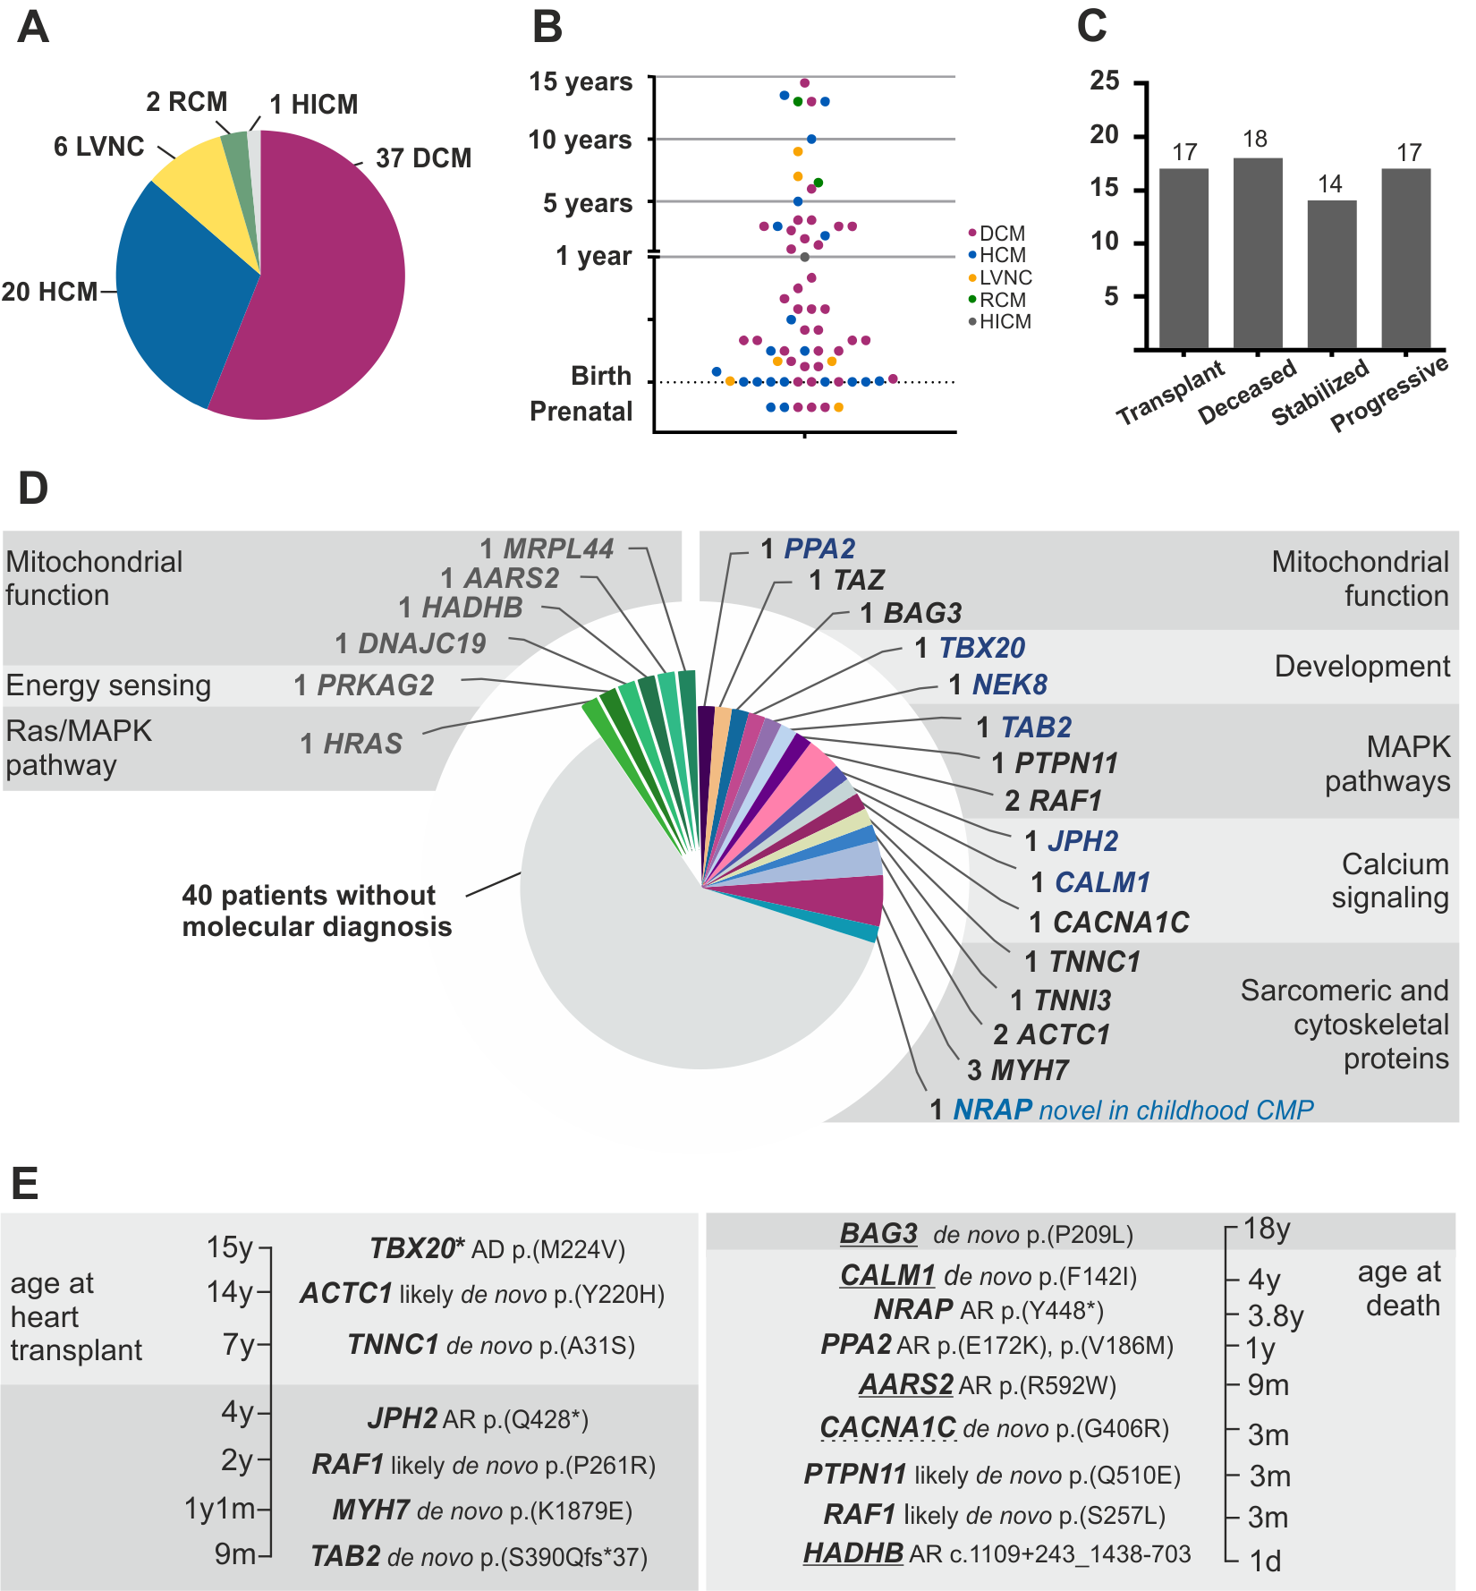
Figure 1

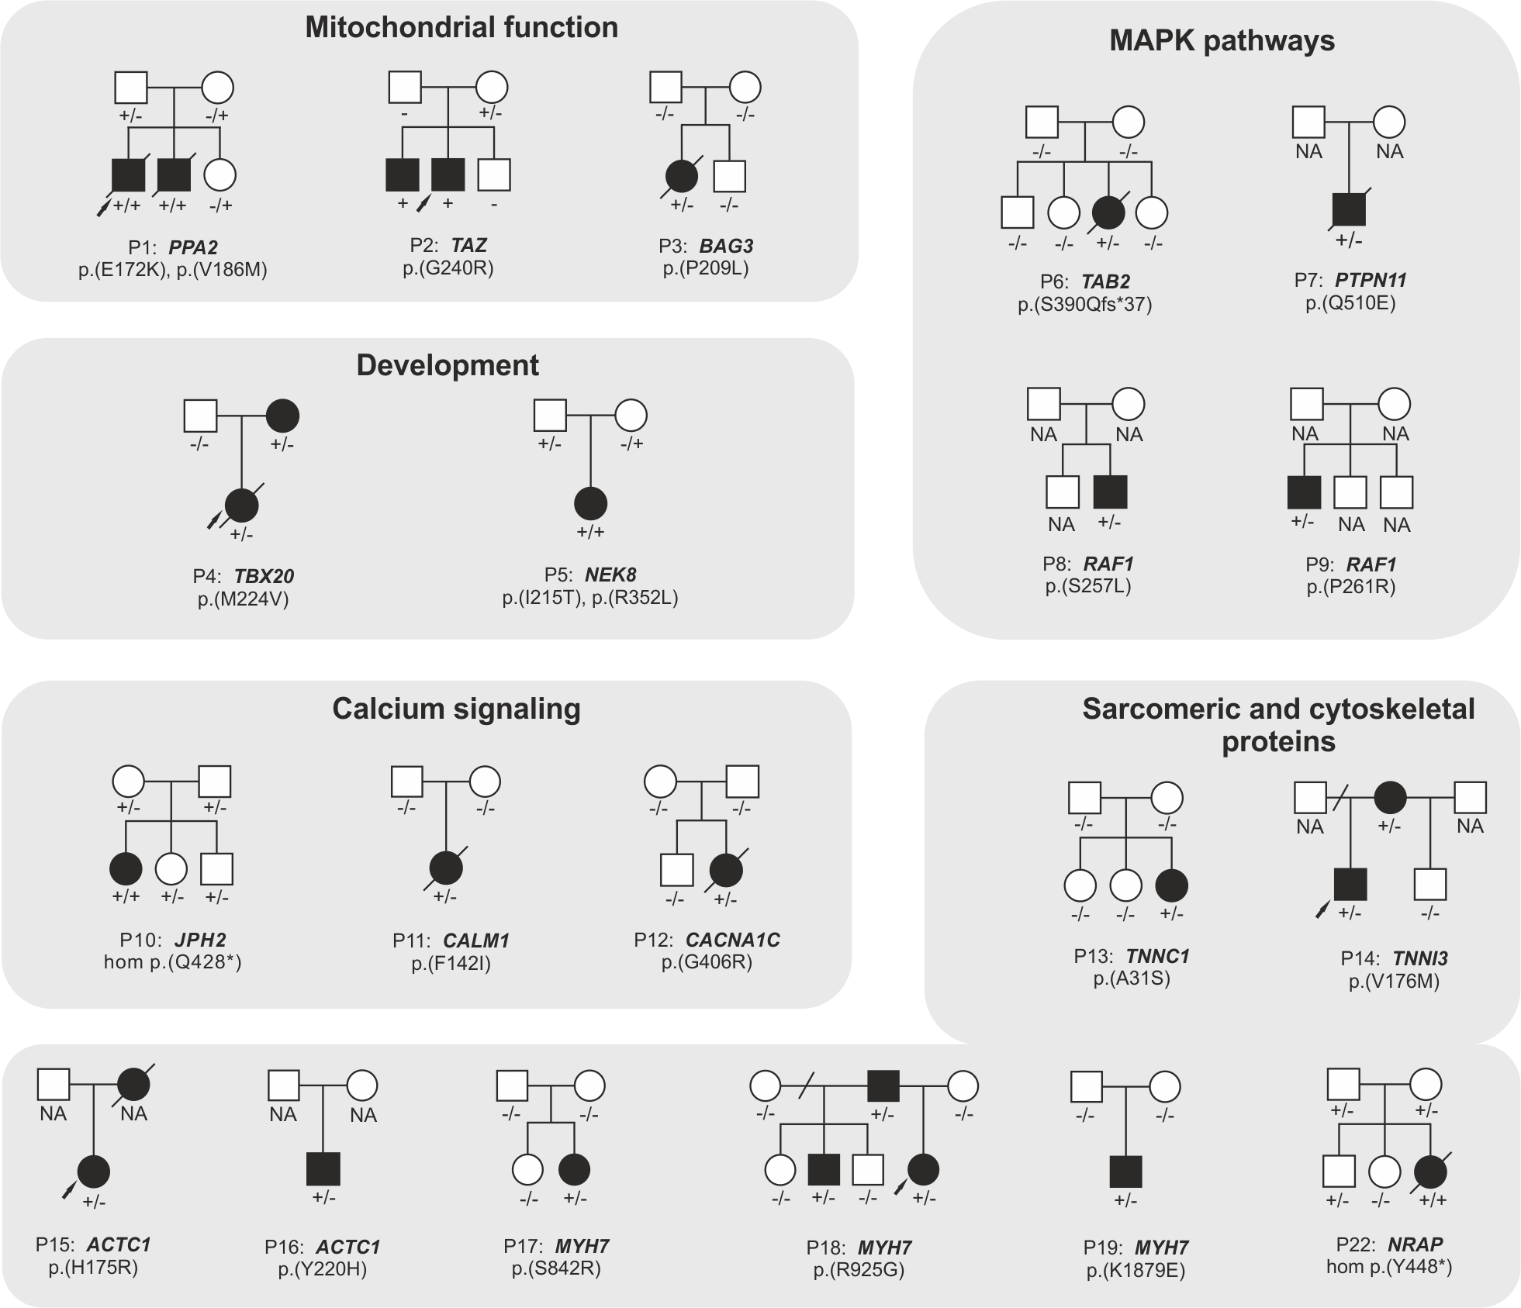
Figure 2

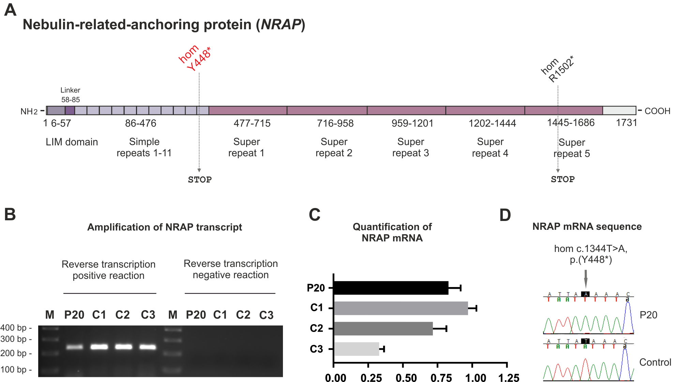
Figure 3

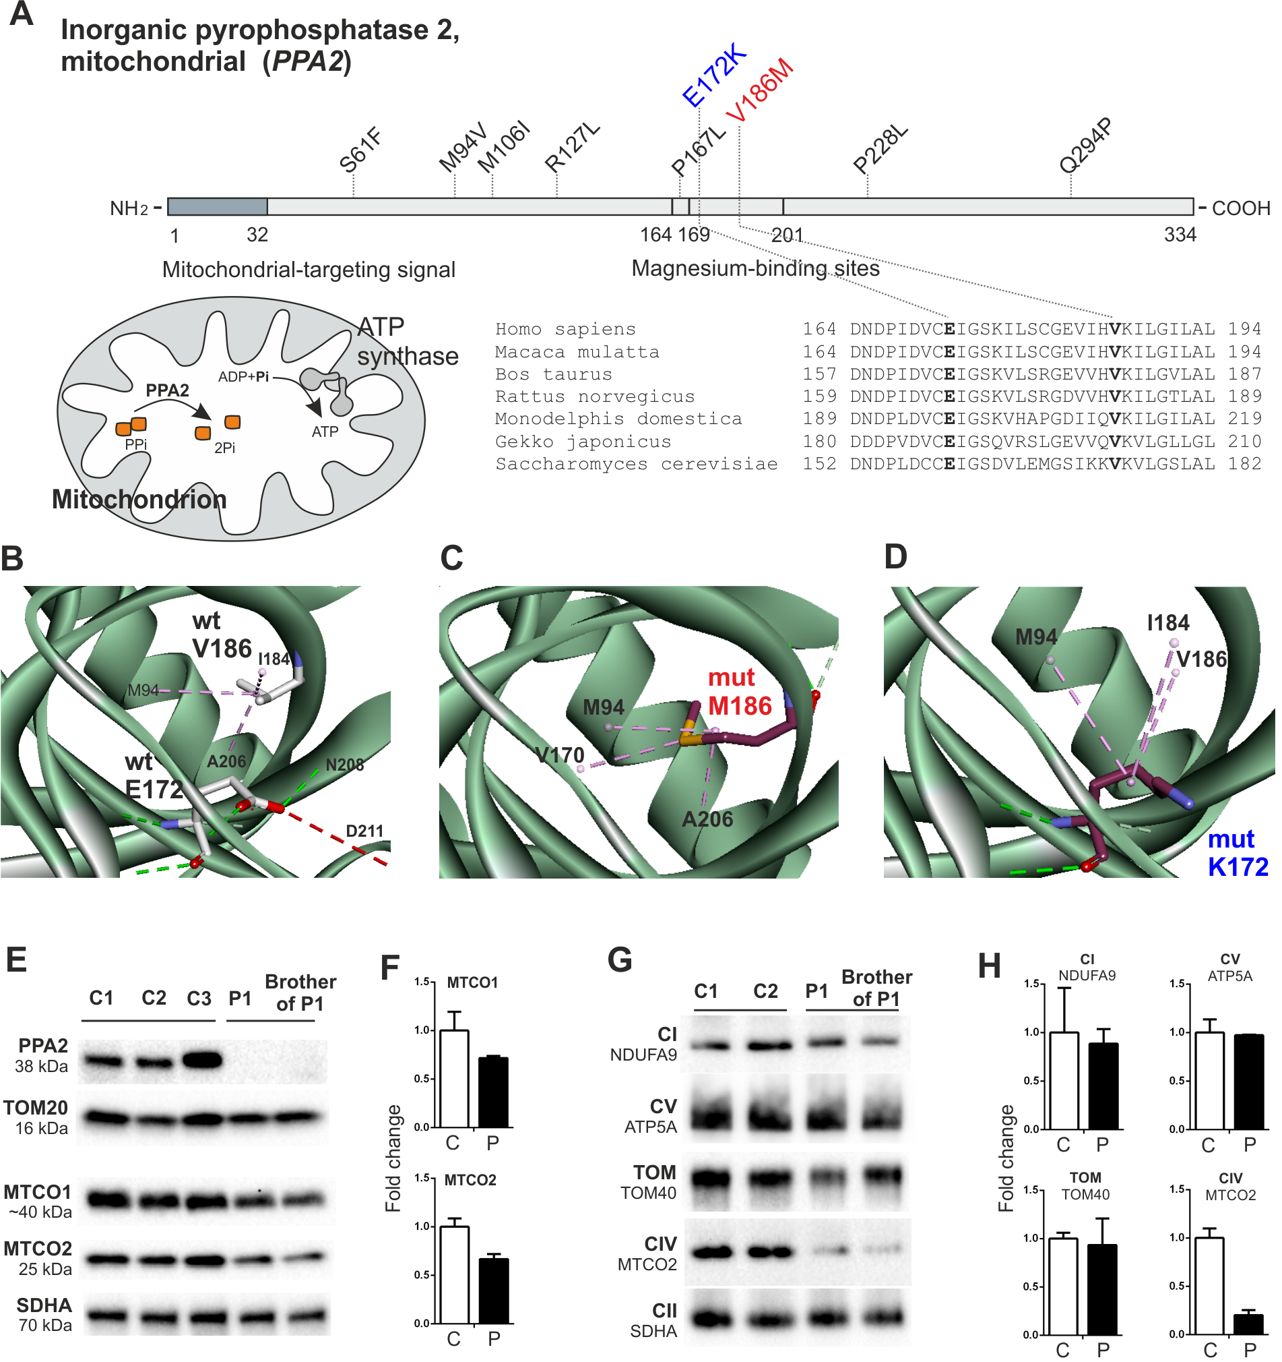
Figure 4

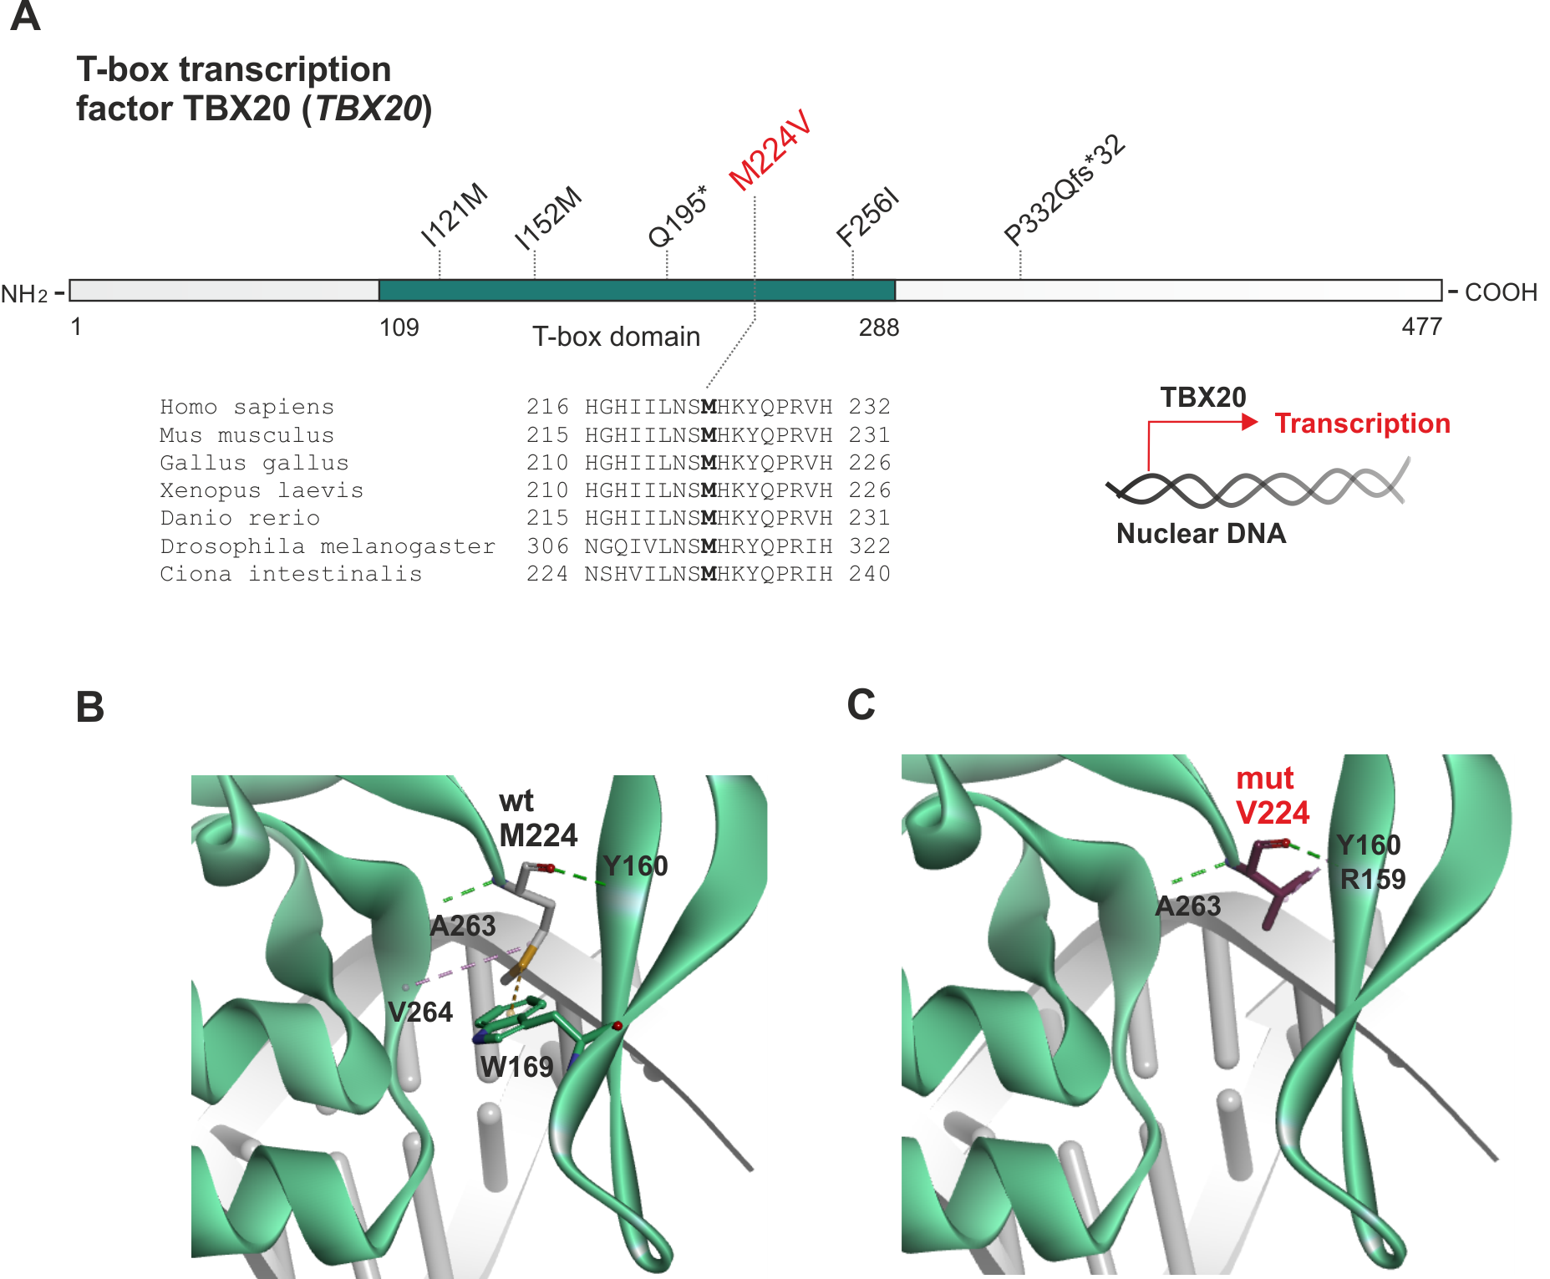
Figure 5

