Early introduction of food reduces food allergy – con
Dr Michael R Perkin

From the Population Health Research Institute, St George's, University of London
Consultant in Paediatric Allergy

Address:
Room 1.29, 1st Floor, Jenner Wing
Population Health Research Institute
St George's, University of London
Cranmer Terrace
London, SW17 0RE

Tel: 020 8725 2786
Email: m.perkin@sgul.ac.uk

Only one study of the early introduction of allergenic food or foods into an infant’s diet has produced truly compelling results – the LEAP study.^{1,2} The EAT study showed no effect in the intention to treat analysis,³ neither did the STAR study⁴ nor did the HEAP study.⁵ And the LEAP study truly did work – an 81% reduction in the primary outcome of peanut allergy in the intention to treat (ITT) analysis. An ITT analysis “avoids overoptimistic estimates of the efficacy of an intervention resulting from the removal of non-compliers by accepting that noncompliance and protocol deviations are likely to occur in actual … practice”.⁶
And here is the rub - the LEAP study did not allow participating families the option of noncompliance. LEAP families received weekly phone calls from 4-11 months of age monitoring compliance and exhorting families in the consumption group to keep eating and the avoidance group to avoid, these calls continued fortnightly phone from 12-30 months of age, and monthly from 30 to 60 months of age. Thus a family enrolling a 4 month old onto the LEAP study were telephoned 104 times to remind them to eat or avoid peanut. Hence the overall rate of adherence to the two assigned interventions was 92.0%. This is about as divorced from “actual practice” as is possible. The LEAP team have rebuffed this by stating that mothers achieved the recommended consumption level within the first month after enrolment, the implication being that they were not being cajoled into adherence. However, those same mothers were fully aware that they were going to be phoned again and again and again about their adherence so an independent perspective might be to say that resistance was futile…
What about the real world?
So, in essence the LEAP study is a scientific proof of principle, it says nothing about what would happen if you asked the same high risk participants to undertake the same intervention in actual practice. Let us assume that, miraculously, the same level of adherence was achieved and hence the results could be extrapolated into the real world, would it make much of a difference to the burden of peanut allergy that a country experiences? The answer is a difference, but not the seismic shift that one might be hoping to see.
Two centres have extrapolated the LEAP results to their paediatric populations: Ireland and Australia. O'Connor and colleagues calculated that there would be a substantial effect on the incidence of PA in Irish children who meet the 2 most objective LEAP criteria of severe AD or egg allergy, with a relative reduction in the incidence of PA of 71%.⁷ However, the population-level effect is much less dramatic with only a 29% relative reduction, because LEAP-defined high-risk children only produce a minority of cases of peanut allergy in Irish children (488/1202 cases per annum).
Even the more optimistic Australian calculation, by Koplin and colleagues, would still only result in just under half of expected cases of peanut allergy (48% - 20 case of PA instead of 41 per 1000 children) being prevented when the LEAP data was extrapolated to the HealthNuts population.⁸
The difference between the Irish and Australian estimates rests on the Australian’s determination that 16% of their HealthNuts cohort would have met the enrolment criteria for the LEAP study through either an egg allergy or severe eczema. This compares with a figure of 4.8% of the Irish children being eligible.
The latter is a much more realistic figure as the HealthNuts egg allergy figure was based on raw egg allergy,⁹ and the actual number of children that would be identified as being eligible for the LEAP study intervention in real life would be much lower as very few young children are exposed to raw egg.
Need to do it for ever
In the LEAP-On study there were 3 new cases of peanut allergy in the LEAP consumers who had been asked to avoid peanut for 12 months. There were also three new cases of peanut allergy in the avoidance group and hence there was no statistical significance, but this belies an interesting observation hidden in a supplementary table of the LEAP-on publication.² Not surprisingly LEAP consumers were more circumspect about stopping peanut consumption and per protocol adherence with stopping was only 69.3% in this group. Closer inspection of the spectrum of adherence to the request to stop eating peanut reveals a dose response relationship between the degree to which a mother listened to this advice and the likelihood of her child having a peanut allergy (Figure 1).
The question is – would these three cases have emerged if the families had carried on feeding their child peanut? The answer would seem obvious – it would not. Hence far from the conclusion of the LEAP-On publication that sustained tolerance has been achieved, I believe lifelong consumption is the reality of what has to be recommended.
Why just peanut, what about the 10 tree nuts, what about all the other principal allergenic foods?
Allergy to egg¹⁰ and milk¹¹ is likely to be outgrown, so there is an argument for saying why make wholesale changes to the age at which these foods are introduced into the diet, when allergy to these foods has such a good prognosis? Even 20% or so of children outgrow peanut allergy.¹² However clearly the majority of children with allergy to peanuts, tree nuts, fish or sesame are unlikely to outgrow these problems. Hence the logical extension of LEAP which is leading to families I see in clinic already asking why should they not be actively introducing all the other tree nuts into their infant’s diet. Presumably when they are 4-6 months of age. And then eat them ad infinitum.
Nutritional implications of extrapolating LEAP to other nuts
However such an intervention is likely to have significant nutritional consequences, the long term impact of which are unknown. Helen Brough has been leading the Pronuts study, looking at the efficacy of introducing multiple nuts into a child’s diet to induce tolerance. In the Pronuts study for child 11 years of age or older, consumption of 10 nuts/seeds at 13g per portion of each nut twice weekly results in 260g of nuts being consumed per week. This means that 14.1% (240/1700 kcals) of the child’s calories come from nuts alone. However for this precise reason, Pronuts has already had to be a significant compromise compared with what the LEAP children ate. Pronuts 1-4 year olds ate 10g of each nut per week. LEAP infants ate the equivalent of 24g of peanut per week. Consuming the same quantity of 10 nuts/seeds would mean 240 grams of nuts per week which would be 22% of a 1-4 year olds 1000 kcal requirement.
International guidelines
The LEAP study has already prompted international organizations to re-examine their allergy prevention advice. A consensus communication was produced that was most noteworthy for its circumspection: “Infants with early-onset atopic disease, such as severe eczema, or egg allergy in the first 4 to 6 months of life might benefit from evaluation by an allergist or physician trained in management of allergic diseases....Evaluation of such patients might consist of performing peanut skin testing, in-office observed peanut ingestion, or both....”¹³ The Australians have adopted a simple recommendation that solids should start at around 6 months and not before 4 months and that “all infants should be given allergenic solid foods including peanut butter, cooked egg, dairy and wheat products in the first year of life. This includes infants at high risk of allergy.”¹⁴

So what age should do you really need to start at
The rationale for recommending 4-6 month introduction of peanut in high risk infants in the new USA guidelines is again an extrapolation arguably over and beyond what the results show. LEAP participants were enrolled between 4 and 10 months of age. In fact a recent publication based on an analysis of the publicly available LEAP data claims that the likelihood of being peanut tolerant was significantly higher with peanut introduction between 6-10 months of age than at 4-6 months of age.¹⁵
This seems counter intuitive given that children are not born with positive skin prick tests and hence logically the earlier the introduction the better. However in making any statements in this age range it is worth remembering just how few infants were enrolled onto the LEAP study at this age: 24 four month olds and 95 five month old infants. Thus early age specific recommendations are being made on the basis of just 63 pre six month old consuming LEAP infants.
However it is interesting to note if one goes back to the original paper by du Toit which led to the LEAP study being initiated, that in the Kaplan-Meir estimate for the age at which peanut was introduced (Figure 1 of their paper) it can be seen that virtually no Israeli chid had peanut introduced under 6 months of age.¹⁶
Furthermore, it seems very likely that there is not a panacea age at which all solids can be realistically introduced and tolerance then ensue. EAT raised many heckles by enrolling infants at 3 months, but in reality they started their first solids as they turned four months. However, this was already too late for 7 participants who had enrolment positive food challenges, five of whom fulfilled the study primary outcome for food allergy (Table S29A in the EAT results paper). Given there is no realistic prospect of commencing any earlier than the 3-4 months of EAT, particularly in breastfed infants, it seems likely that food allergy is not going to disappear entirely no matter what early introduction regimen gets recommended.
Safety
The issue of safety is paramount. Both LEAP and EAT suggested that the early introduction of peanut and other allergenic foods was safe. However clearly the early introduction of pasteurised raw whole hen’s egg powder in the STAR study was not. 31% (15/49) of four month old infants in the active arm reacted to their pasteurized raw whole egg power, 10 on first exposure, 1 with anaphylaxis,⁴ and the early introduction of pasteurised raw hen’s egg white powder in the BEAT study was frankly, dangerous: 6% (23/406) of infants were already sensitised (specific IgE ≥0.35 kU/l) at enrolment, 17 of whom underwent double blind challenge with pasteurized raw egg white powder of whom 16 reacted, 3 with anaphylaxis. In the active group 2/142 (1.4%) were allergic, both reacted at home on first exposure, one with anaphylaxis.⁵ Hence the choice of allergen vehicle appears to be critical.
An algorithm based on measuring sensitisation will be impossible to implement
The USA have now gone further, producing an algorithm based guideline for preventing peanut allergy. For infants with severe eczema, egg allergy, or both one should “strongly consider” evaluation by specific IgE and/or SPT and, if necessary, an oral food challenge and based on test results, introduce peanut-containing foods at between 4 and 6 months of age.¹⁷
This constitutes a screening programme in everything but name. It therefore seems timely to remember what are the criteria by which a proposed screening programme should be assessed (Table 1).¹⁸ By no metric can the undertaking of skin prick or specific IgE testing on all children with egg allergy and/or severe eczema be considered easy, and undertaking promptly the subsequently required food challenges on a systematic population based scale I would argue is near impossible.
So do the Irish who stated “...community implementation would demand huge additional resources at all levels of health care. Further studies need to be performed to assess many unresolved aspects of peanut introduction.”⁷
And so do the Australians who concluded that “a population program aiming to identify and screen all infants at risk of peanut allergy would pose major cost and logistic challenges that need to be carefully considered.” The co-author of that paper, one Gideon Lack.⁸
That the LEAP screening algorithm being proposed is so time critical has already been demonstrated with a case report of a peanut skin prick test negative infant who undertook his peanut challenge one month later and had anaphylaxis.¹⁹ As the LEAP team responded, this was much more likely to reflect the emergence of sensitisation in the intervening one month than the report author’s contention that it was an anaphylactic reaction in a skin prick negative child. Regardless the LEAP team recommended that consumption of peanut or, where necessary, a supervised oral food challenge should take place immediately on the day the SPT is performed.
Is a societal change in consumption the only realistic way for it to be effective?
Such a screening regimen is never going to be successfully introduced at a society level, whether by the USA or anyone else. The question therefore is what happens with the results of the LEAP and EAT studies.
Here, I think the Australians are closer to being right. Israel, which started this whole research enterprise off, does not systematically screen its infants for latent peanut sensitisation, they simply nearly universally eat peanut by one year of age. Surely therefore, if we are going to do anything then we simply should follow their footsteps and encourage active early consumption. That this seems safe at a societal level is reflected in the fact there was not a single death from peanut allergy when food allergy mortality in Israel between 2004-2011 was reviewed.²⁰
However, if what happens in Israel were universally propagated, it seems inevitable that somewhere there will be a fatality in an infant whose family will state that they were introducing peanut earlier than they previously would have done. The question is whether society will be able to acknowledge that that is a price that almost inevitably will be paid for preventing a much greater amount of food allergy morbidity and mortality in older children and adults.

References:
1. Du Toit G, Roberts G, Sayre PH, Bahnson HT, Radulovic S, Santos AF et al. Randomized trial of peanut consumption in infants at risk for peanut allergy. N Engl J Med 2015; 372(9):803-13.
2. Du Toit G., Sayre PH, Roberts G, Sever ML, Lawson K, Bahnson HT et al. Effect of Avoidance on Peanut Allergy after Early Peanut Consumption. N Engl J Med 2016; 374(15):1435-43.
3. Perkin MR, Logan K, Tseng A, Raji B, Ayis S, Peacock J et al. Randomized Trial of Introduction of Allergenic Foods in Breast-Fed Infants. N Engl J Med 2016; 374(18):1733-43.
4. Palmer DJ, Metcalfe J, Makrides M, Gold MS, Quinn P, West CE et al. Early regular egg exposure in infants with eczema: A randomized controlled trial. J Allergy Clin Immunol 2013; 132(2):387-92.
5. Bellach J, Schwarz V, Ahrens B, Trendelenburg V, Aksunger O, Kalb B et al. Randomized placebo-controlled trial of hen's egg consumption for primary prevention in infants. J Allergy Clin Immunol 2016.
6. Gupta SK. Intention-to-treat concept: A review. Perspect Clin Res 2011; 2(3):109-12.
7. O'Connor C, Kelleher M, O'B Hourihane J. Calculating the effect of population-level implementation of the Learning Early About Peanut Allergy (LEAP) protocol to prevent peanut allergy. Journal of Allergy and Clinical Immunology 2016; 137(4):1263-4.
8. Koplin JJ, Peters RL, Dharmage SC, Gurrin L, Tang ML, Ponsonby AL et al. Understanding the feasibility and implications of implementing early peanut introduction for prevention of peanut allergy. J Allergy Clin Immunol 2016; 138(4):1131-41.
9. Osborne NJ, Koplin JJ, Martin PE, Gurrin LC, Lowe AJ, Matheson MC et al. Prevalence of challenge-proven IgE-mediated food allergy using population-based sampling and predetermined challenge criteria in infants. J Allergy Clin Immunol 2011; 127(3):668-76.
10. Sicherer SH, Wood RA, Vickery BP, Jones SM, Liu AH, Fleischer DM et al. The natural history of egg allergy in an observational cohort. J Allergy Clin Immunol 2014; 133(2):492-9.
11. Wood RA, Sicherer SH, Vickery BP, Jones SM, Liu AH, Fleischer DM et al. The natural history of milk allergy in an observational cohort. Journal of Allergy and Clinical Immunology 2013; 131(3):805-12.
12. Peters RL, Allen KJ, Dharmage SC, Koplin JJ, Dang T, Tilbrook KP et al. Natural history of peanut allergy and predictors of resolution in the first 4 years of life: A population-based assessment. Journal of Allergy and Clinical Immunology 2015; 135(5):1257-66.
13. Fleischer DM, Sicherer S, Greenhawt M, Campbell D, Chan E, Muraro A et al. Consensus communication on early peanut introduction and the prevention of peanut allergy in high-risk infants. Journal of Allergy and Clinical Immunology 2015; 136(2):258-61.
14. ASCIA Guidelines: Infant feeding and allergy prevention. 2016.
15. Secondary analysis of the effect of skin test size and age of introduction on peanut tolerance among the LEAP study participants. WILEY-BLACKWELL 111 RIVER ST, HOBOKEN 07030-5774, NJ USA, 2016.
16. Du Toit G, Katz Y, Sasieni P, Mesher D, Maleki SJ, Fisher HR et al. Early consumption of peanuts in infancy is associated with a low prevalence of peanut allergy. J Allergy Clin Immunol 2008; 122(5):984-91.
17. Togias A, Cooper SF, Acebal ML, Assa'ad A, Baker JR, Beck LA et al. Addendum guidelines for the prevention of peanut allergy in the United States. Pediatr Dermatol 2017; 34(1):5-12.
18. Wilson JMG, Jungner G. Principles and practice of screening for disease. 1968. Geneva, World Health Organization.
19. Rabinovitch N, Shah D, Lanser BJ. Look before you LEAP: Risk of anaphylaxis in high-risk infants with early introduction of peanut. Journal of Allergy and Clinical Immunology 2015; 136(3):822.
20. Levy MB, Goldberg MR, Nachshon L, Tabachnik E, Katz Y. Lessons from cases of mortality due to food allergy in Israel: cow's milk protein should be considered a potentially fatal allergen. Isr Med Assoc J 2012; 14(1):29-33.

Figure 1. Adherence to LEAP-On recommendation to stop eating peanut in LEAP consumers
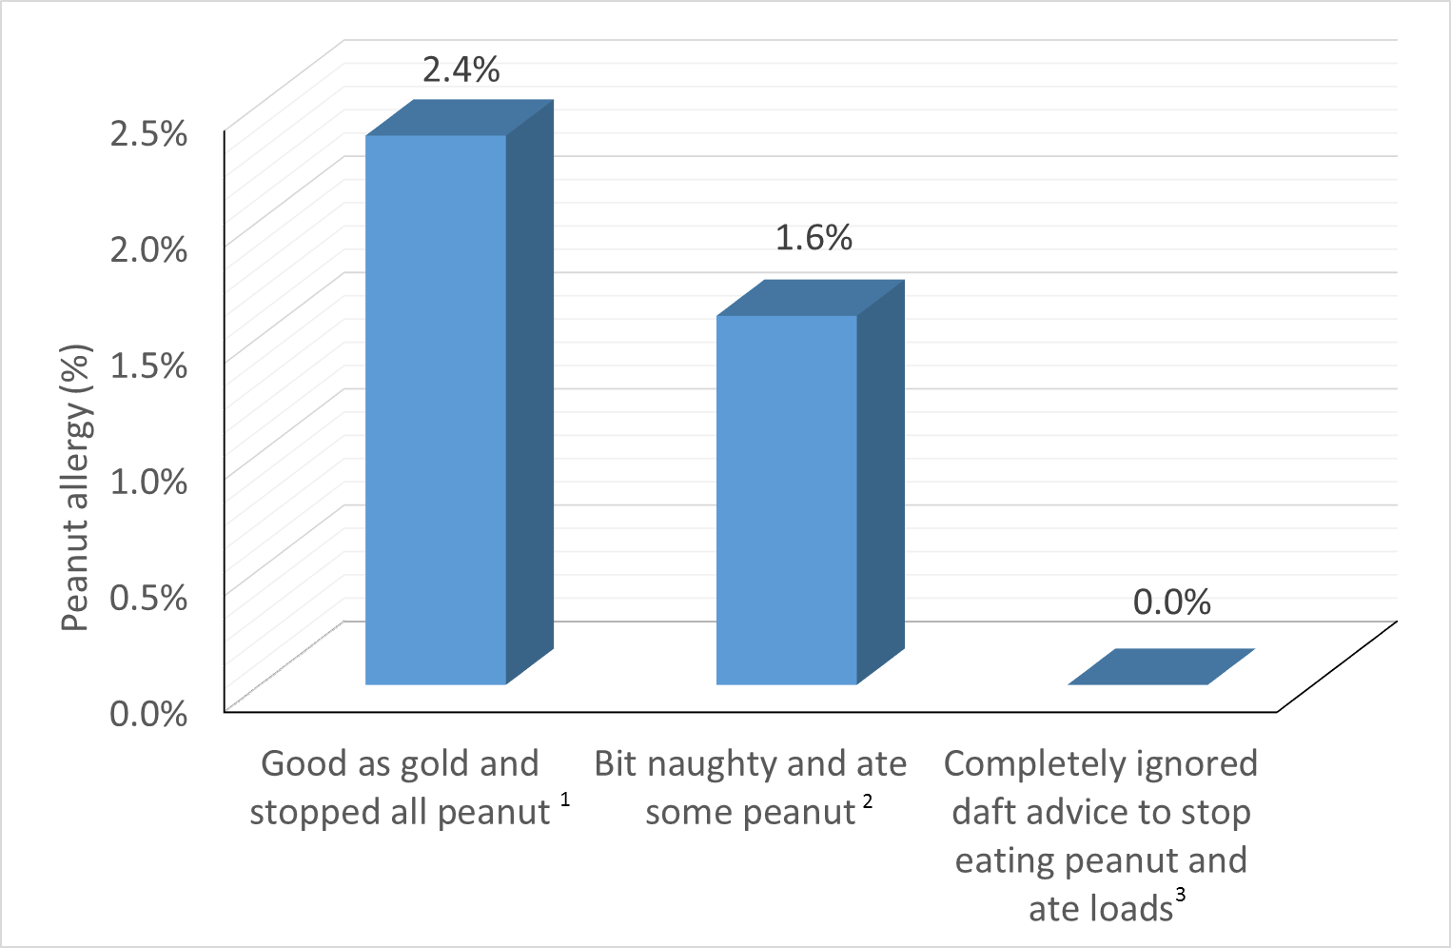
This figure is based on the data given in Table S3 of the LEAP-On study publication.² The column headings in my figure are adulterations of the originals in the table, namely: ¹complete avoidance of peanut (3 cases of peanut allergy out of 127 LEAP consumers); ²consumption of some peanut - per protocol (1/63); and ³consumption of some peanut - not per protocol (0/65). Per-protocol consumption was defined as: no more than 2g of peanut protein on 6 occasions over a period of 12 months with a maximum of 1 event per month AND no more than 1g of peanut consumption on 12 occasions over a period of 12 months with a maximum of 2 events per month

Table 1: Wilson & Junger critera for a screening programme¹⁸
- the condition should be an important health problem
- the natural history of the condition should be understood
- there should be a recognisable latent or early symptomatic stage
- there should be a test that is easy to perform and interpret, acceptable, accurate,
reliable, sensitive and specific
- there should be an accepted treatment recognised for the disease
- treatment should be more effective if started early
- there should be a policy on who should be treated
- diagnosis and treatment should be cost-effective
- case-finding should be a continuous process

